IOS Press, The final draft post-refereeing of the accepted article:

Statistical Journal of the IAOS, vol. 37, no. 4, pp. 1247-1274, 2021

Published: 26 November 2021

DOI 10.3233/SJI-210834

Urban Green. Integrating ecosystem extent and condition data in urban ecosystem accounts. Examples from the Oslo region

Per Arild Garnåsjordet*, Margrete Steinnes**, Zofie Cimburova***, Megan Nowell***, David N. Barton*** and Iulie Aslaksen****. *Statistics Norway and Norwegian Institute for Nature Research (NINA), Oslo, Norway. **Statistics Norway, Kongsvinger, Norway. ***Norwegian Institute for Nature Research (NINA), Oslo, Norway. ****Statistics Norway, Oslo, Norway

**Abstract:**

The article enhances the knowledge base for the assessment of urban ecosystem services, within the United Nations System of Environmental-Economic Accounting Ecosystem Accounting (SEEA EA), recently adopted as an international statistical standard. The SEEA EA is based on spatial extent accounts (area of ecosystems) and biophysical condition accounts (ecological state of ecosystems). Case studies from the Oslo region are explored, combining land use/land cover maps from Statistics Norway with satellite data. The results illustrate that a combination of land use/land cover data for ecosystem extent and detailed satellite data of land cover provides a much higher quality for the interpretation of extent and condition variables. This is not only a result of applying spatial analysis, but a result of applying knowledge about the information categories from satellite data of land cover, to official statistics for built-up land in urban areas that until now have not been identified. Moreover, the choice of spatial units should reflect that modelling of different ecosystem services, as a basis for trade-offs in urban planning, requires a combination of different spatial approaches to capture urban green elements.

**Keywords:** Ecosystem accounting, ecosystem services, urban ecosystems, spatial analysis, land use maps, land cover maps

**JEL classification:** Q34, Q56, Q57, Q58

**Acknowledgments**:

Funding from the Research Council of Norway (NFR), MILJØFORSK programme, for the URBAN EEA project (NFR project 255156), and from the Mapping and Assessment for Integrated ecosystem Accounting (MAIA) project funded by the European Union’s Horizon 2020 research and innovation programme under grant agreement No 817527, is gratefully acknowledged. The authors thank Rezvan Hashemi of Statistics Norway for technical support with maps.

# 1. Introduction

The article explores the United Nations System of Environmental-Economic Accounting Ecosystem Accounting (SEEA EA) applied for urban green areas as a basis for mapping of urban ecosystem services. Following the development of a statistical standard for a System of Environmental-Economic Accounting (SEEA), the United Nations Statistics Division initiated the development of the SEEA Ecosystem Accounting (SEEA EA), first presented in 2014 [1], then tested out and further developed in different versions [2] [3] [4], and in 2021, it was adopted by the United Nations as an international statistical standard [5].

The SEEA EA is based on spatial extent accounts (area of ecosystems) and biophysical condition accounts (ecological state of ecosystems). Urban ecosystems are complex, with elements of green in-between built-up areas. A key issue in further development of the SEEA EA is to explore relations between data sources for extent and conditions accounts, in order to represent the elements of urban green in between built-up areas, as basis for assessment of use of ecosystems and ecosystem services.

Using case studies from the Oslo metropolitan region combining land use/land cover maps and satellite data of vegetation, for study areas in the Oslo region, the article presents an approach that captures the urban green elements by combining data sources to get richer measures of ecosystem extent within urban areas. The analysis contributes to the application and development of SEEA EA for urban ecosystems, considering challenges in defining urban ecosystem extent and differentiating extent from condition [6].

Urban green areas vary from areas with natural vegetation to built land with no natural vegetation. Even areas with natural vegetation will be impacted by urban population use. There will be a mosaic of urban green areas with different land use and land cover, from agriculture and forestry in the periphery of the urban area, to an increasing complexity of land use towards the city center where built-up land use will dominate, and where only single trees and patches of “artificial” green areas, e.g. lawns and urban gardens on roof-tops, may be expected. Such “artificial” green areas can be separately identified in the classification system, and their area can be part of a measure of extent, while the changing composition can be a measure of condition. In SEEA EA [5], Chapter 13, the top-down and bottom-up challenges of mapping urban green areas are dealt with as a landscape approach (para. 13.108) and an ecosystem asset approach (para. 13.109).

In urban ecosystem accounting, the challenge is to replicate a spatially diverse mosaic of urban green in a useful way through the combination of the information in extent and condition accounts. Different categories of urban green areas may be assessed from different sources. Land use maps give information on land use and land cover classes, e.g. forest, agriculture and built-up land, and include green elements such as public parks, sport facilities, and cemeteries. In the following, this is called "land use and cover classes" to avoid misinterpretation. Satellite data give information on the ecosystem condition, in terms of trees, grassland, or other types of vegetation. We explore how the extent accounts include elements from the condition accounts, in order to capture the mosaic of urban green spaces, and we describe the spatial change in the share of green elements.

The article contributes to the development of the SEEA EA thematic urban ecosystem accounting, in particular detecting green elements within built-up urban areas which are not easily identified in existing land use statistics. Combining land use/land cover maps with satellite imagery gives information on vegetation that is not available in land use/land cover maps, thereby enhancing the capture of urban green elements. A study from Canada demonstrated that combining radar data and satellite imagery improved characterization of urban ecosystems and suggested a practical method for measuring and monitoring changes in green urban areas [7].

A European study of mapping ecosystem services includes a number of measures of urban environmental quality, such as percentage of built-up area, and measures of urban ecosystem quality, such as percentage of urban green space, percentage of natural area, canopy coverage, and connectivity and fragmentation of urban green spaces [8]. The European study developed a method for selecting indicators for ecosystem condition in ecosystems prioritized in EU environmental policies, based on pressures, types of ecosystem services and policy relevance [8]. The most important pressure type in urban ecosystems is land conversion. The most important indicator for urban ecosystem services is urban green space. The most important indicators for urban ecosystem condition are (1) annual land conversion to built-up area, (2) percentage share of urban green area and built-up area, (3) size of conservation areas, (4) canopy areas of trees, and (5) agricultural land [8]. These five indicators are, however, as much extent variables as condition indicators, and thus illustrate the connection between the concepts of extent and condition. The need for a multi-layer system to include different sources of information on ecosystem extent and condition is generally accepted within the SEEA EA [4]. While it is clear that extent is a measure of area, it is recognized in the SEEA EA that if a measure of condition is also dependent on area, then that is a related but separate question. Indeed, of these five indicators there are four that require measures of ecosystem extent, but are not in themselves measures of extent. We consider them to be condition indicators related to landscape configuration, and they illustrate the importance of using ecosystem extent data to support measurement of ecosystem condition.

In an urban context, land use information can be used to map green structures like parks, agricultural patches and sports fields, but green elements, e.g trees or small lawns intertwined in the urban mosaic of built-up areas, will not be identified by land use maps. We have to find ways to supplement the information from land use maps in order to identify green structures defining condition and predicting ecosystem services.

In the assessment of ecosystem services, property information from the cadaster might be a useful overlay of information for measurement of the supply and use of ecosystem services, from a given set of ecosystem assets with measures of extent and condition. Information on the legal access to land is needed in order to assess accessibility to green areas and the possibility to provide recreation services, an important aspect of the knowledge base for physical planning and urban land use policy [9] [10]. The accessibility to urban green spaces may be more or less restricted, ranging from private gardens without public access, to public parks and green corridors.

However, the cadaster does not provide ideal spatial units, since the environmental quality of properties can be heterogenous and they vary greatly in size. It should be considered to include another layer of information, i.e., one that determines potential use and public access. For example, if a tree-covered lot is owned by a corporation, it may be sold for development.

This article identifies two important indicators: the share of urban green, expressing information on vegetation from satellite imagery, and public access to urban green areas, based on cadastre information on property boundaries and supplementary information on the extent of public access. In future development of urban ecosystem accounting, more research is needed to model the use of different ecosystem services and to assess who is the user of green areas and who might benefit from the urban ecosystem services. Ecosystem accounting standards require allocating physical ecosystem service supply across users. For this purpose, in addition to data from surveys of use of urban green areas, information on property boundaries and public access is needed. Delineation of property boundaries becomes an important statistical unit for urban land use statistics. At the property level it is possible to identify the share of urban green and different types of land use/land cover and density of vegetation on the non-built-up part of the property.

While the article contributes to the development of the SEEA EA urban ecosystem accountingit is beyond scope of our case study approach to give a complete overview of urban ecosystem condition and urban ecosystem services in the Oslo region. The city of Oslo is surrounded by large forest areas, with public access secured by legal rights, and the nature areas near the city have great importance for recreation. In further research, as a basis for improving land use statistics, the improvements in urban ecosystem accounting reported here for the case study areas can be applied to develop ecosystem accounting for the entire urban region with its diversity of ecosystem services and available recreation possibilities. In future work, spatial changes in ecosystem extent may be connected to the actual supply and use of the ecosystem services and may facilitate modelling of the capacity for bundles of ecosystem services.

## 2. Central concepts in SEEA EA Ecosystem Accounting

The purpose of the SEEA EA is to develop a spatial and ecological basis for assessments of ecosystem services, based on spatially explicit extent accounts (area of ecosystems) and biophysical condition accounts (ecological state of ecosystems) [5], as defined in para. 2.13: “***Ecosystem extent is the size of an ecosystem asset in terms of spatial area. Ecosystem condition is the quality of an ecosystem measured in terms of its abiotic and biotic characteristics***”. (Fig. 1).

**Figure 1: The SEEA EA core ecosystem accounts**

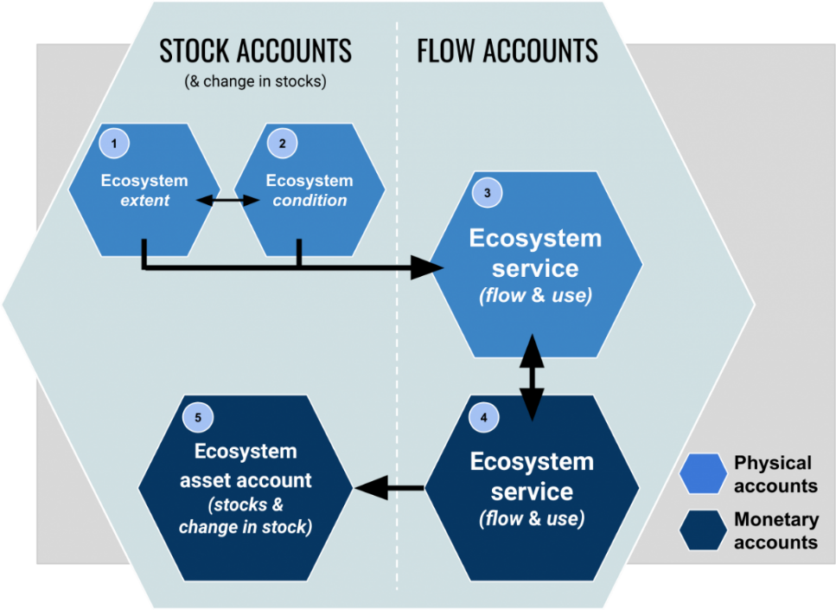

**Source**: https://seea.un.org/ecosystem-accounting

The system of ecosystem accounts consists of five core ecosystem accounts, see Fig. 1, being linked together through definitions and classification and through geographical references. The starting point for ecosystem accounting is organizing information on the extent (area) of different ecosystem types within a country or region. A complete system of ecosystem accounts can be represented as a table of status and change in extent and condition of the ecosystems inan area, with an opening extent account (in hectares or km2), additions and reductions in extent, and a closing extent account. The case studies in this article present status at a given time, not change over time. The structure of a basic ecosystem extent account can be illustrated in maps, giving a spatial representation of the ecosystem and its vegetation, as basis for land cover and land use. An ecosystem account table can be made for the chosen ecosystem types, usually being classified in terms of land cover or land use.

In this article we focus on the extent and condition accounts, based on a spatial representation of ecosystems and their biophysical properties. These two accounts are the building blocks for ecosystem accounting. We explore the knowledge base required for future modelling of ecosystem services supply and use account, assessed in physical terms and monetary terms. This is necessary to show how ecosystem services are distributed spatially and who are the users of the ecosystem services. However, this modelling is beyond the scope of this article. The next step in ecosystem accounting, after establishing extent and condition accounts, is the modelling of the supply and use of ecosystem services. Assessments of the relationship between ecosystem capacity and ecosystem services provide knowledge for analysis of societal trade-offs between prioritized ecosystem services and policy choices involved. It is important to select a geographical reporting unit matched by maps available to the public and the management agencies, and with focus on areas that represent different bundles of ecosystem services, such areas important for biodiversity, areas with different types of users, and areas representing policy trade-offs.

The spatial perspective supports the linking of the components of the accounting framework and is reflected in the definition of an ecosystem asset [5], para.2.11. “***ecosystem assets are contiguous spaces of a specific ecosystem type characterized by a 27 distinct set of biotic and abiotic components and their interactions***”.

Fig. 2. Relationships between spatial units for SEEA EA ecosystem accounting (extent accounts)

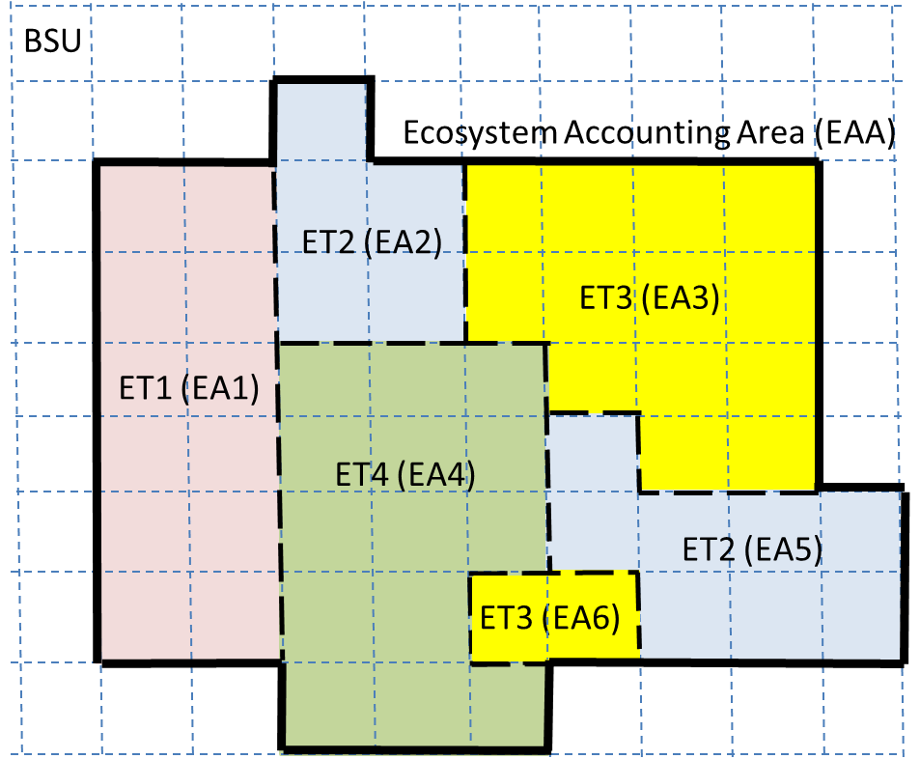

**BSU**: Basic Statistical Unit

is a grid system

**EA**: Ecosystem Asset, continuous parcels of different ecosystem types

**ET**: Ecosystem Type

**EAA**: Ecosystem Accounting Area is the area for statistical reporting of ecosystem accounts

**Source:** Adapted from [1], Fig. 2.4.

The basic concepts for spatial units in SEEA EA ecosystem accounting (Fig. 2) are Basic Spatial Unit (BSU), Ecosystem Asset (EA) and Ecosystem Type (ET) in an Ecosystem Accounting Area (EAA). BSUs are units that may vary in size and can be aggregated or disaggregated. In principle the EAs should be homogeneous and distinct spatial areas forming the conceptual base for ecosystem accounting and integration of relevant statistics.[1] ETs are aggregates of individual EAs of a specific type of ecosystem (e.g. deciduous forests). ETs are identified and delineated in the process of ecosystem accounting. An EAA, which is the area the statistics is produced for, may vary in size and is normally an administrative area, but could also be defined by natural boundaries, e. g. watersheds.

The SEEA EA establishes the ecosystem asset as the conceptual spatial unit for ecosystem accounting. The BSU is an approach to the measurement of ecosystem assets. Ecosystem assets are not fixed over time, but may change in size reflecting changes in extent. Within the spatially fixed BSUs the information about each pixel can change over time, e.g. when changing land use or land cover leads to a change in ecosystem type, changing the extent of the associated ecosystem asset.

Statistical units are basic building blocks in all types of official statistics, e.g. persons, households, social groups, companies, properties, industrial sectors, public sector units, municipalities, regions and nations. Such units are well defined and classified, often as part of international standard classification systems. It is challenging to classify ecosystems in the same way. While the SEEA EA recognizes the richness of ecosystems, classification is a core component of accounting. Borders between ecosystems are usually not distinct, and although ecologists describe ecosystems as geographical units, they are aware that these units are linked in a complex ecological and spatial web that makes it difficult to define specific units. Ecologically, connections between ecosystems may be as important as the borders between them. Ecotones can be classified as separate ecosystem types, if information is available[2]. In general, however, it is important to distinguish between major ecosystem types since this classification frames how ecosystem condition measures are selected and ecosystem services attributed.

Ecosystem condition, in Fig. 1, is generally measured by collating indicators for various ecosystem characteristics for different Ecosystem Types (ETs). In SEEA EA ecosystem accounting, the focus is on ecological integrity (see e.g. para. 5.14 and 5.42, in [5]). Within this broad framing there are different approaches to the measurement of ecosystem condition, ranging from more aggregated to more detailed data on vegetation, biodiversity, soil type, hydrology and climate. In this article the main indicators of the ecosystem condition of urban land cover are greenness and vegetation structure (ground cover and tree canopy cover)

Although ecosystem capacity accounts are not a core account of SEEA EA and part of the SEEA EA standard, extent and condition accounts represent a basis for modelling the capacity for providing ecosystem services [5], para. 2.14. In development and analysis of ecosystem accounts it is important to explore how current use of ecosystems and ecosystem assets (Fig. 3) may affect the capacity of the ecosystems to provide different bundles of ecosystem services in the future. Moreover, assessment of capacity is necessary for moentary valuation of ecosystems as assets. The information categories for extent and condition accounts should be linked to the capacity of the ecosystem to sustain ecosystem services today and in the future. These accounts are the basis for analysis of ecosystem capacity. As we explore in the urban context, combining information from extent and condition accounts will contribute to increase the precision and usefulness of the information categories to give a better estimate of the ecosystem capacity to deliver ecosystem services.

**Fig. 3. Extent accounts and condition accounts, as basis to model capacity and use of ecosystem services**

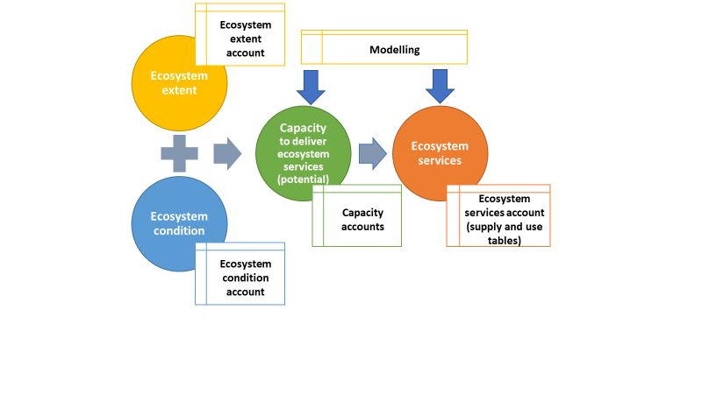

**Source:** Adapted[3] from [8].

Different ecosystem services are based on different types of spatial units, and we need different types of spatial approaches to model different ecosystem services, as basis for the analysis of trade-offs between ecosystem services, such as trade-offs in urban planning, between urban densification, extensification and protecting urban and peri-urban green space. In urban areas, there is a large overall pressure on remaining natural green spaces, and their value is very high, for sustaining biodiversity, and for environmental amenities for the population. For urban ecosystems there is a need to deal with the complexity of how ecosystem services are generated and being used. This flexibility in spatial approach will also make it easier to apply the large amount of available geospatial data, as well as big data platforms for information on transactions and prices on housing.

**3. Description of study areas and reasons for their selection**

The case study areas outside the city center have been selected to represent different stages of the urban transformation processes currently taking place in the Oslo region with extensive plans for urban densification around train- and metro-stations [11]. The Oslo region comprises two different counties, Oslo and Akershus (now Viken), with a common regional strategy focusing on efficient public transport systems, densification of buildings, and the reduction of GHG-emissions, while having a strong focus on the green urban structure [11].

An urban area may be defined in different ways, depending on the purpose of statistics, analysis and research, and on the type of policy that relevant knowledge is being called for. Eurostat defines a functional urban area as a city and its commuting zone, i.e. an urban area consisting of a densely inhabited city and a less densely populated commuting zone whose labour market is highly integrated with the city [12].

In the selection of study sites, particular focus is on areas considered for urban densification [9]. The results presented in this article can contribute to improve the statistical knowledge base for urban planning, land use management and policy, analysis of urban residential prices, and improve the knowledge base for trade-offs between protecting urban green areas and densification of urban areas, and thus to address several aspects of sustainable development of urban areas.

Case study areas were selected along a rural-to-urban gradient, from the city center of Oslo and northeastwards where there is a corridor of urbanized areas within suburban and rural areas. The case study areas outside the city center were selected because of their relevance for the planned urban transformation processes, where many residential areas in and near the city center are planned to be transformed into densely populated areas with apartment buildings, as well as transformation from agricultural land to urban areas outside the city.

The two first case studies are the city center (the main street Karl Johan) with few residents and a mainly residential area (Akersveien) near the city center. The third case study area is a residential area (Grefsen) in Oslo with plans for large scale densification. The fourth case study area (Nittedal) is a suburban area in a neighboring municipality, well within commuter distance to Oslo, and it has been largely developed recently. The fifth case study area (Årnes) is at the boundary of commuter distance, and still with much green area. In the direction of this transect from Oslo there is a long distance to the next city further north, hence the influence of Oslo dominates the urbanization pattern. Characteristics of the study areas are summarized in Table 1.

Table 1 presents indicators for distance, population and labor market for the five case study areas in the Oslo region along a transect of urban areas in the city and in the commuting zone. The Oslo region has about 1.2 million inhabitants and the area is approximately 5 500 km2. In the case study areas outside the city there are so far no large urban concentrations. However, these areas are being considered for concentrated urban development in connection with regional transportation plans. The aim of the regional plans isto increase public transportation and reduce climate emissions from transportation. The distance between the case study areas is shorter near the city center.

**Table 1. Indicators of distance, population and labor market for case study areas in the Oslo region. 2017**

|  |  |  |  |  |
| --- | --- | --- | --- | --- |
| **Name, Municipality** | **Distance from city center, km** | **Population per km2** | **Jobs per km2** | **Characterization** |
| Old city center,  Karl Johan street, Oslo | 0 | 6 674 | 62 419 | Central, railway station |
| Akersveien, Oslo | 1 | 16 374 | 11 181 | Urbanized |
| Grefsen, Oslo | 8 | 6 296 | 4 078 | Dense single-housing |
| Nittedal | 16 | 2 223 | 245 | Commuter distance, 30 minutes by train |
| Årnes | 80 | 1 404 | 2 365 | Rural, 50 minutes by train |

Note: The number of jobs in the city center may be exaggerated as in some cases all employees are assigned to the main office.

Source: Statistics Norway

For the Oslo region, the land use/land cover maps from Statistics Norway and Sentinel-2 maps provide the same general picture for agricultural land and forest (Fig. 4), since the definition of the classes for forest and agriculture are based on the same definitions as in the land use maps (the AR5 map that is updated piecewise by municipalitie using a combination of registration and orthophotos, see Section 4). However, forest land cover may be picked up by Sentinel-2 as agricultural land, For the built-up area, the classification is based on land use data being administrative data sets classifying the entire area of a property by land use type (Fig. 4, middle panel), while the focus of the satellite data is the vegetation type (Fig. 4, lower panel). Especially for the city center of Oslo, Fig. 4, lower panel, based on Sentinel data shows more urban green, as compared to the land use/land cover map in Fig 4, middle panel.

**Fig. 4. Land use/land cover map from Statistics Norway (middle panel) and Land cover (Sentinel-2 land cover classification) (lower panel) for the Oslo region in 2017. Case study areas along an urban-rural gradient**

|  |
| --- |
| Et bilde som inneholder kart  Beskrivelse som er generert med svært høy visshetEt bilde som inneholder kart  Beskrivelse som er generert med svært høy visshet |
| Et bilde som inneholder kart  Beskrivelse som er generert med svært høy visshet |
| Et bilde som inneholder kart  Beskrivelse som er generert med svært høy visshet |

Each case study area is 1 km2 or 100 ha. Varying patch size of greencover may result in differences in classification accuracy of both extent and condition of urban areas and natural habitats [13].

# 4. Data sources and methods

**4.1 Data sources**

Combining administrative spatial data sources like cadastral data with high quality land use maps as a strategy to achieve a map for ecosystem extent units has recently been adopted in the UK [14] [15] and the Netherlands [16] [17] [18] [19]. To identify condition of urban green in the land use data, these have been supplemented with land cover maps derived from satellite imagery.

The data consist of land use maps from administrative data sources being used in measuring ecosystem extent, combined with land cover classification at 10-meter resolution from the Sentinel-2 satellite. The high spatial resolution of the data will allow for combining them into a measure of ecosystem extent that increases the precision of the combined data sets. This flexible integration of data sources is expected to be useful for assessments of different types of ecosystem services which require different resolutions and classifications.

Land cover maps derived from the freely available Sentinel-2 satellite imagery with a 10-meter resolution seem promising for this purpose. The frequent revisit time (2 days near the poles) offers flexibility for frequent updating of land cover maps and compensation for cloud cover. Alternatively, imagery from the Rapid Eye satellite at 5-meters resolution may be purchased. This has recently been used in Germany for a detailed mapping of urban green in private and public properties in two German cities [20].

While Rapid Eye has better resolution and daily revisits, it only has 5 bands, one of which is red-edge. Sentinel-2 is particularly well-suited to detecting vegetation. It has 13 spectral bands and four additional spectral bands for capturing the red-edge spectrum, in addition to the red and near-infrared bands. However, these red-edge bands are at 20 m spatial resolution which may be insufficient to capture some vegetation structure such as individual tree canopies [21]. In this study we demonstrate the use of Sentinel-2 imagery (see 4.2). We also present aerial photos to show location of buildings and built-up areas.

## *4.2 Current land use classification approach by Statistics Norway for land use/land cover maps*

Statistics Norway publishes annual statistics on land use and land resources in Norway. The statistics are based on the combination of a wide range of digital map data put together into one detailed, nationwide map of land use and land resources. Land cover for non-built-up are derived from the land resource map AR5 produced by the Norwegian Institute for Bioeconomics (NIBIO). The main division in AR5 is area type which is divided into: fully cultivated land, surface cultivated land, infield pasture, forest, bog, open land, water, snow/glacier, built-up area, transport and not mapped [22]. The map is detailed, and largely corresponds to a scale of 1: 5 000. Changes are mapped through continuous updating in the municipalities as well as periodic updating nationally. It takes 4-5 years between each time a municipality undergoes the periodic updating [23].

For built-up areas the most important data sources are:

* The cadaster (“Matrikkelen”): National register of properties and buildings (Continuously Updating)
* Common map database (FKB “Felles Kartdata Base”): Collection of detailed maps (1:5 000) for a wide range of elements such as buildings, roads, harbours and other infrastructure, industrial sites, sport-grounds, playgrounds and parks. Buildings are updated rapidly, whereas updating from the other sources may have a time lag of several years.

The land use and land cover map is made using the best quality data available. However, when optimal data cannot be obtained, data of simpler quality are utilized. For example, roads mapped as detailed polygons are used where such data exist, but if data are not available, roads are represented by lines and extended by a buffer zone to give it a polygon representation. The method is in practice an automatic geographic information system (GIS) that delimits, classifies and puts the data together into a hierarchy, using the data sets with highest accuracy first. The principle is shown in Fig. 5, but in reality, many more datasets are involved [24]. The resulting land use/land cover map (Fig. 5) is both as updated and complete as possible. A limitation for accounting purposes is that the source data have different peridcity of updating, so the combined map does not have single time stamps.

**Fig. 5. Principle of overlaying different maps in Statistics Norway´s land use/land cover map**



**Source**: AR5: Land cover map (1:5000) (bottom layer), Cadaster: National register of properties and buildings (middle layer) and FKB (Common map data base): Land use maps (1:5000) (top layer).

The land use/land cover maps give a considerable amount of information detail about the type of urban development and built-up areas, as illustrated in Fig. 6. However, other than clearly delineated green areas, such as parks and sports areas, other green elements, such as single trees, in-between the built-up areas urban mosaic are not visible in the land use maps.

**Fig. 6. The result of combining maps from different sources, an example of a land use/land cover map from Statistics Norway**

This area from Sinsen

north-east of Oslo city center

illustrates the complexity of information that may be obtained for the classification of land use.

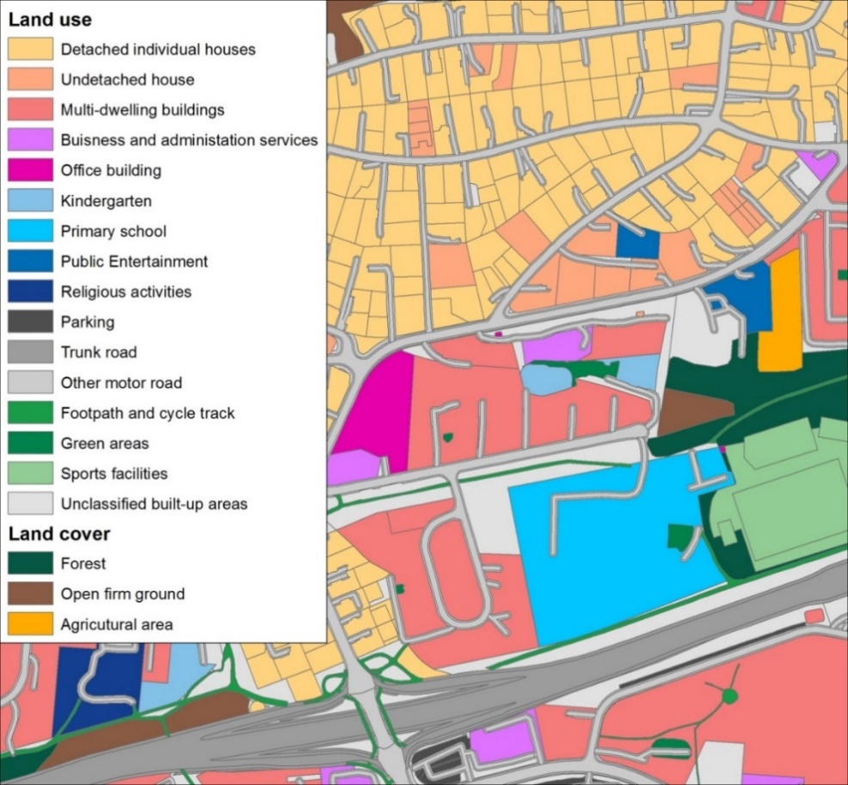

## *4.3 Land cover map from Sentinel-2 satellite data*

Sentinel-2 is a high-resolution multi-spectral earth observation mission of the EU Copernicus Programme, developed and operated by the European Space Agency. It consists of two polar-orbiting satellites (Sentinel-2A and Sentinel-2B), enabling revisit time 2-5 days in mid-latitudes. Each satellite carries an optical instrument that samples 13 spectral bands in the visible, near-infrared and short wave infrared spectral range. The spatial resolution of the imagery varies between 10, 30 and 60 m. The objective of the Sentinel-2 mission is referred to as application in land monitoring, emergency management, security and climate change monitoring [25].

It is important to use satellite imagery from the leaf-on period (between June and August) to capture the full extent of vegetation. In this study, Sentinel-2 imagery acquired for two cloud-free days in the summer of 2017 was combined to derive a land cover map of the case study area. The satellite imagery was classified into five land cover classes relevant for the analysis of urban ecosystems (namely water, tree canopy, grass, built-up land and agriculture). A “random forest” classification model was trained on all spectral bands and an additional Normalized Difference Vegetation Index (NDVI) band, at 10m spatial resolution [26] [27] [28] [29] [30]. Training data for the classification model were 20 000 points randomly distributed across the study area. After the exclusion of 549 invalid training points, land cover class was assigned to each remaining training point either manually based on an orthophoto[4] image or automatically, using the Statistics Norway land use/land cover map in scale 1:5 000.

We achieved 83 per cent overall classification accuracy, however, there is a large variation amongst the accuracy of individual land cover classes. The highest accuracy (93 per cent) was achieved for the tree canopy and water classes, whilst the accuracy of the agriculture, built-up land, and grass classes is relatively low (74 per cent, 70 per cent and 23 per cent, respectively). The agriculture class was not differentiated based on the current state of the crops (if they were growing, ready for harvest or harvested), but only on the land use definition (from AR5). This variation between exposed soil (when crops are harvested) and vegetation reduced the classification accuracy, because both open soil and crops were included in the training data for the agriculture class, and this led to misclassification in urban areas. Furthermore, lower accuracy of the class built-up land is explained by misclassification of impervious areas (e.g. paved parking lots) as open soil, as well as misclassification of building shadows as water. The lowest accuracy was achieved for the grass class, as grass was often misclassified as tree canopy.[5] This was most likely due to the mixed pixel effect where grass and tree canopy often occupy the same pixels in urban green areas. In principle, for analysis of urban ecosystems all the green areas might be put into one common class. By including radar imagery from Sentinel-1, one might have been able to decrease these misclassifications [31].

## 4.4 *Methodology combining map and satellite data*

The raster land cover map from Sentinel-2 imagery obtained by the above-mentioned approach[6] was then vectorized and intersected[7] with the land use/land cover map from Statistics Norway. In the land use/land cover map for built-up land, we know actual land use from cadaster data, but not the land cover. For example, the red areas, i.e. known land use, unknown land cover, in Fig. 7 may be a parking lot or they may be trees or a garden with grass. The Sentinel-2 map enables detection of land cover such as tree canopy in Fig. 7.

In order to make it easier to compare the two maps in Fig. 7, the Sentinel-2 land cover map is visualized as semi-transparent on top of an orthophoto, in order to show the streets and buildings**.** The concepts of land use/land cover are often misinterpreted because the difference is not always obvious (several classes may overlap) when comparing with a land cover map using Sentinel-2.

“Green areas” in the upper panel of Fig. 7 are defined as green spaces within built-up areas, rather than actual green land cover (lower panel of Fig. 7). It points to the limitations of data and perhaps the limitations of the definitions in data sources and possibly the SEEA.

The cadaster data identify land use types and the FKB identify built structures. Thus, these data sources are not suited for identifying ecosystem extent. While the national map AR5 is based on land cover, explained in Section 4.2, the mapping is not updated uniformly across the country. Moreover, in urban areas much of the green areas are within built-up areas. Thus, land use/land cover maps in urban areas will only give limited information about urban green, because very much of the urban green is classified as developed land. Developed land is not only built-up land, but also parks, lawns etc. within the urban area. By combining the data sources, it is possible to estimate how large a share of the “red” area in Fig. 7, the unknown land cover in the land use/land cover map, that actually is green, i.e. with trees and lawns.

**Fig. 7. Principle for combination of Statistics Norway land use/land cover maps and Sentinel-2 land cover classification (raster map). Example from a case study area (Akersveien)**

|  |  |
| --- | --- |
|  |  |
|  | The red circle is an area with a paved (asphalt) school yard and a back yard used for parking space.  The green circle is an area for housing with a back yard with trees.  The blue circle is an area with a playground which is paved (asphalt), but with trees around. Green pixels represent vegetation cover classification |

**4.5 Limitation of data sources and methods**

The satellite imagery was selected for the specific study areas in this project. In future work, however, it would be necessary to establish a standard, possibly national product that would be accessible for others working on ecosystem accounting in the area. The misclassifications of land use and land cover classes are a common issue and could be worked out by better ground truthing, a priority in future work.

A possible limitation of the SEEA EA approach is that if the condition of an ecosystem changes substantially, it will become another ecosystem type (ET). The current ET classification (based on the IUCN GET) uses about 100 classes globally, only a handful of which are present in any one country. Including condition measures into such a classification (e.g., high/low density, low/medium/high vegetation structure) would result in a complex classification system, which would be unique to each study. It is therefore simpler to identify what exists on the ground (e.g., trees, types of trees) and combine condition information as separate layers (age class, density, level of disturbance). Using consistent spatial units also has its advantages, for example, by treating data as a tabular database (e.g., defining the ecosystem type and condition of a particular cell of the table).

# 5. Results: Combination of land use/land cover data and satellite data for urban case study areas in the Oslo region

In the following analysis of the case study areas, the first step is to combine the different data-sources, from Statistics Norway (SSB) land use/land cover maps and Sentinel-2 land cover map and explore the share of urban green areas. This is displayed in figures for each case study area with four types of maps**[8]**: (A) Land use/land cover maps, (B) Aerial photo to show location of buildings and built-up areas, (C) Sentinel-2, NDVI and orthophoto, (D) Private and public green areas. Map D is the contribution of our analysis and represents the proposed combination of information on the green share and the public access. The share of urban green is also visualized by statistics, i.e. the share of green calculated from the two data sources, are displayed in bar diagrams, where the red areas represent areas with known land use and unknown land cover. The following analysis of combining the maps and summarizing the land use information in bar diagrams forms the basis for comparing the information content of the land use/land cover maps and Sentinel-2 satellite data maps. The urban green elements only appear when these two data sources are combined, expressing the need for integration of the information basis for extent and condition accounts.

## *Case study area: Old city center, Karl Johan street, Oslo*

In the old city center of Oslo, around the main street of Karl Johan, with an old quarter in the south east in map A (Fig. 9), a planned grid city structure from the 1600s is still visible, outlined both to avoid fires, but also with defined open spaces. The open areas are large areas close to the waterfront with still some harbor functions, a lot of that area being just public space.

The satellite picture in map C (Fig. 9), shows that there are green areas, mostly trees, around the old Akershus Fortress, but also along the main street Karl Johan with public space with little grass, but a lot of large trees. The same can be seen around the cathedral and the stock market exchange building. The street structure in map C is not from the satellite map, but from an underlying photo in map B, to make it easier to compare two maps A and C. In map C, we observe misclassification of building shadows as water in the city center. In the case of building shadows, it is easy to filter out these misclassifications. Sentinel-2 also provides a differentiation of tree canopy from grass which is a simple indicator of green space condition, not covered by AR5. Map D shows that there are not any private green areas in the city center. The light grey areas are private apartment buildings.

**Fig. 8. Old city center, Karl Johan street, Oslo. Comparing the information content of the map of land use/land cover and the map of Sentinel-2 satellite data. 2017**

The Sentinel-2 data and the land use/land cover data provide different statistics on the share of urban green and share of built-up, as shown in Fig. 8. The red area is known land use, unknown land cover. The data of the land use/land cover statistics regarding built-up and developed land differentiates between buildings (close to 45 per cent of the total area) and infrastructure (mostly roads, about 25 per cent). Of the open non-built-up land in developed areas, a substantial part is trees, which are not captured in the land use/land cover maps. Sentinel-2 overestimates water, due to misclassification of building shadows as water, but has probably better estimates for grassland.

An interesting feature is that open non-built-up land in developed areas is over 15 per cent, which is high, compared to what is anticipated for areas of city centers [32]. Most of the green area in the Oslo city center, shown in Fig. 9 (part D), is accessible to the public.

**Fig. 9. Case study area: Old city center, Karl Johan street, Oslo. 2017**

|  |  |  |  |
| --- | --- | --- | --- |
| A- Land use/land cover maps  Et bilde som inneholder tekst  Beskrivelse som er generert med svært høy visshet | | C- Sentinel-2, NDVI and orthophoto Et bilde som inneholder kart  Beskrivelse som er generert med svært høy visshet | |
| B- Aerial photo  Et bilde som inneholder stor  Beskrivelse som er generert med svært høy visshet | | D- Private and public green | |
| A | C | | D |

## *Case study area: Grefsen, Oslo*

Grefsen is a typical residential area of Oslo, densely developed with mostly single-family residences surrounded by gardens, and the area is close to the city center, easily accessible by tram and metro. Originally the gardens parceled out late in the 1800s in this residential area were quite large. A certain amount of “normal” densification has taken place, in terms of building additional single-family homes in the gardens, as indicated by map B (Fig. 11).

The Grefsen area epitomizes the trade-off between concentrated urban densification for climate mitigation and protecting the green areas of the city. Some years ago, the Oslo city planning authorities proposed a densification zone (map B) with 12 story buildings which would dramatically have changed the area. Peoples’ protests were massive and at present the proposal has been withdrawn and removed from the city plan. Most of the area of Grefsen is developed (map A) and apart from the private gardens, there is not much open green area left, but as can be observed from the Sentinel-2 map (map C), this is a very green area despite its closeness to the city center.

The densification process, clearly anchored in political ambitions to increase availability of housing, has been going on for decades, but it has been carried out with a strong regulation of building heights. In addition to the availability of public transportation nearby, and a tram line going through the residential area, there is a well-developed road system. In this rather affluent middle-class residential area, the car has been an important transportation mode. Today bicycle has become a very popular transportation mode because of the relative short distance to the city center.

Map C shows that the Sentinel-2 classification has misclassified some areas as agricultural areas, although they clearly are not. In this case, they mainly belong to two large sport facilities. Altogether, the vegetation of the Grefsen area is a mix of trees and lawns, representing an attractive urban landscape, as would be expected in a 70-100 years old residential area.

Fig. 10. The residential area Grefsen, Oslo. Comparing the information content of the map of land use/land cover and the map of Sentinel-2 satellite data. 2017

Fig. 10 illustrates the differences in information content between the map of land use/land cover and the map of Sentinel-2 satellite data. The statistics for this comparison are quite as expected, moving out from the city center. Here the urban green areas are mostly private gardens. In this case study area, private green areas are much larger than public green areas, although there are several quite large public green areas as well, many of them are sports and school facilities.

**Fig. 11. Case study area: Grefsen, Oslo. 2017**

|  |  |  |  |
| --- | --- | --- | --- |
| A- Land use/land cover maps | | C- Sentinel-2, NDVI and orthophoto  Et bilde som inneholder tekst, kart, sitter  Beskrivelse som er generert med svært høy visshet | |
| B- Aerial photo  Et bilde som inneholder krets  Beskrivelse som er generert med svært høy visshet | | D- Private and public green | |
|  |  | |  |

**Table 2. Land use in the case study areas, per cent and hectares (ha). 2017**

|  |  |  |  |  |  |
| --- | --- | --- | --- | --- | --- |
|  | Karl Johan | Akersveien | Grefsen | Nittedal | Årnes |
| **Sentinel-2 (Map C)** |  |  |  |  |  |
| Built-up | 88.3 | 68.9 | 73.2 | 46.0 | 44.5 |
| Agricultural |  | 1.1 | 1.3 | 2.0 | 19.9 |
| Trees | 5.4 | 25.9 | 15.1 | 36.1 | 25.3 |
| Grass | 1.7 | 3.9 | 10.4 | 15.7 | 9.1 |
| Water | 4.6 | 0.1 |  | 0.2 | 1.2 |
| **Land use/land cover (Map A)** | | | | | |
| Built-up | 70.7 | 52.7 | 49.0 | 28.5 | 26.8 |
| Developed | 23.0 | 25.6 | 43.5 | 56.5 | 40.1 |
| Agricultural |  | 1.4 |  | 0.6 | 18.8 |
| Trees | 0.0 | 2.4 |  | 10.5 | 2.6 |
| Grass | 2.5 | 16.1 | 7.4 | 3.2 | 10.5 |
| Water | 3.7 | 1.9 |  | 0.7 | 1.2 |

Note: The number of hectares corresponds to the percentages as each case study area is 100 ha. Sums may equal 99.9 due to rounding.

Tables 2, 3 and 4 are generated on the basis of maps, to illustrate the difference in information content. Table 2 illustrates the difference in land use from Sentinel-2 land cover map and land use/land cover maps from Statistics Norway. To compare, we need to consider the categories “built-up” and “developed” land, as shown in Table 3, and private and public green, as shown in Table 4.

**Table 3. Developed areas by Sentinel-2 class and land use/land cover from maps, hectares (ha). 2017**

|  |  |  |  |  |  |
| --- | --- | --- | --- | --- | --- |
|  | Karl Johan | Akersveien | Grefsen | Nittedal | Årnes |
| **Panel 1 - Sentinel-2 within developed areas (red areas in map A)** | | | | | |
| Developed, built-up | 18.8 | 19.9 | 29.7 | 26.8 | 20.8 |
| Developed, grass | 0.6 | 0.6 | 5.3 | 9.7 | 4.5 |
| Developed, agricultural | 0.0 | 0.1 | 0.1 | 1.0 | 1.2 |
| Developed, trees | 3.1 | 5.0 | 8.4 | 19.1 | 13.3 |
| Developed, water | 0.6 | 0.0 | 0.0 | 0.0 | 0.2 |
| **Panel 2 - From land use/ land cover maps (areas that are not red in map A)** | | | | | |
| Built-up, buildings | 42.9 | 29.9 | 20.0 | 13.0 | 10.8 |
| Built-up, infrastructure | 27.8 | 22.8 | 29.0 | 15.5 | 16.0 |
| Agricultural | 0.0 | 1.4 | 0.0 | 0.6 | 18.8 |
| Forest | 0.0 | 2.4 | 0.0 | 10.5 | 2.6 |
| Grass | 2.5 | 16.1 | 7.4 | 3.2 | 10.5 |
| Water | 3.7 | 1.9 | 0.0 | 0.7 | 1.2 |
| **Panel 3 - Combination land use/ land cover maps and Sentinel-2** | | | | | |
| Buildings | 42.9 | 29.9 | 20.0 | 13.0 | 10.8 |
| Infrastructure | 27.8 | 22.8 | 29.0 | 15.5 | 16.0 |
| Other artificial surface | 18.8 | 19.9 | 29,.7 | 26.8 | 20.8 |
| Agriculture | 0.0 | 1.4 | 0.0 | 0.6 | 18.8 |
| Trees/forest | 3.1 | 7.4 | 8.4 | 29.6 | 16.0 |
| Grass | 3.1 | 16.8 | 12.9 | 13.8 | 16.3 |
| Water | 4.3 | 1.9 | 0.0 | 0.7 | 1.4 |

Table 3 compares information on the categories “built-up” and “developed” land, from both data sources and summarizes the discussion for the case study areas of how to combine the information.

**Table 4. Land use and public and private green areas in the case study areas (map D), hectares (ha). 2017**

|  |  |  |  |  |  |
| --- | --- | --- | --- | --- | --- |
|  | Karl Johan | Akersveien | Grefsen | Nittedal | Årnes |
| **Combination, maps and Sentinel-2** | |  |  |  |  |
| Green, private | 0.0 | 3.5 | 15.7 | 30.7 | 15.8 |
| Green, public access | 7.0 | 23.2 | 11.1 | 12.7 | 20.1 |
| Grey, private | 2.1 | 25.4 | 28.3 | 29.7 | 12.1 |
| Grey, public access | 87.1 | 42.3 | 44.9 | 15.2 | 29.4 |
| Agricultural |  | 1.4 |  | 0.6 | 18.8 |
| Forest | 0.0 | 2.4 |  | 10.5 | 2.6 |
| Water | 3.7 | 1.9 |  | 0.7 | 1.2 |

Table 4 summarizes the information from maps D in the case study areas. It encompasses all green areas (from Sentinel-2 maps) within the case study areas. For the old city center Karl Johan, the green area is 7 ha, i.e. the green share is 0.7 per cent. For the same case study area, Table 3 (Sentinel-2 data) shows that grass and tree land cover sum to 3.7 ha, within “developed” land, the red area. Land use/land cover maps show that there is 2.5 ha grass, that is parks in the map. The difference between the data in Tables 3 and 4 expresses the simplification made when we use land use/land cover maps and classify areas as built-up or green based on these maps. Then the part of green trees over roads and buildings will not be defined as green. The same is the reason for some deviations in the other case study areas. Agricultural and forest are mostly privately owned, but forest areas are freely accessible to the public, while infield agricultural land is normally not accessible during the growing season, although it is accessible for the public in the winter season.

# 6 Discussion

## *Combination of data sources*

The case studies have demonstrated that the combination of the land cover/land use classifications, both in land use/land cover maps and Sentinel-2 satellite maps, is important for the interpretation of the maps, in terms of actual distribution between built-up areas and green areas, and hence, for the choice of methods for establishing extent accounts. Moreover, using the knowledge about the classification categories gives basis for interpretation rules, required in order to develop statistics, where we need to make rules for interpretation of satellite imagery, and the analysis of the case study areas illustrates what type of interpretation rules are needed.

From the land use/land cover maps it is possible to distinguish the actual area covered by buildings, and to the extent possible, the area with vegetation and type of vegetation of the parcel that can be sorted out by the satellite maps. In fact, at the property level it is possible to sort out different types of land use/land cover and density of vegetation on the non-built-up part of the property. Combining the data sources makes it possible to establish rules for interpretation about which classification source to use when they give contradicting information. Thus, in future work, a link to a determined set of ecosystem types would be beneficial to allow for a link to the structure of accounts and application in decision making. Table 5 summarizes how information from the two data sources are particularly relevant for the case study areas.

**Table 5. Comparing information content in land use/land cover and Sentinel-2 in the case studies.**

|  |  |  |
| --- | --- | --- |
| Case Study | Land use/land cover | Sentinel-2 |
| Old city center, Karl Johan street, Oslo | Streets, public places, markets, and private and public buildings. Large public areas alongside the waterfront, but limited green areas. Some large plots of grasslands are public parks. | Trees and grassland areas can be separated. The data sources allow to separate private green from public green. There are no private residential green areas in the city center. Building shadows are misclassified as water. |
| Akersveien, Oslo | Public parks and graveyards, Water, allotment garden for residents. | Lots of trees and green space, no water identified. The river is dominated by vegetation.  Agriculture misclassified |
| Grefsen, Oslo | No public green except sport areas and public institutions. | No streets, lots of trees and green space in private gardens. Misclassification of agriculture. |
| Nittedal | Buildings and infrastructure.  Forest, water and agriculture are more accurately identified by land use maps. | Private greens and trees. Not much green in the new developed area.  Agriculture misclassified, some water is classified as forest, possibly riparian forest. |
| Årnes | Little green in the old part of the town.  Some new residential expansion on agricultural land. | Private green dominates in the residential areas.  Large public green areas that could be developed, not using agricultural land. |

Table 5 illustrates that a combination of property information and urban green can be of interest, and that different statistical tables may be produced by combing the data sources in different ways. The classification of private and public green and grey areas are based on Sentinel-2 maps, for classes agricultural land, trees and grass. However, some of the green areas from Sentinel-2 overlap with agriculture and forestry from the land use/land cover map and are therefore not included. The total amount of private and public green urban areas is lower than the green urban areas in the Sentinel-2 map. Table 5 illustrates the lack of private green space in and near to the city center. However, close to the city center there are parks large green areas being accessible to the public. These types of tables may provide more details of the type of buildings and land use as well as ownership.

If we can map the content of green areas and trees in each propertycombining information from official land cover and landuse maps and satellites, the overall accuracy of land use statistics could be increased. We may combine these types of data in different ways in an analysis of the capacity for different ecosystem services [33].

Another aspect of the combination of data sources is the possibility to achieve higher periodicity of accounts in order to detect trends in land use/land cover and green structure. The use of satellite data opens up the possibility of algorithms for automatic reclassification of data from land use/land cover maps as basis for ecosystem extent accounts. The long-term ambition of the SEEA Ecosystem Accounting is to produce yearly ecosystem accounts once the system is developed and operative.

However, the objective of annual accounts may be difficult to apply in contexts where land use change is slow and classification error is high so that annual trends will not be observable with statistical confidence. Presented in the Appendix, Fig. A.9 summarizes the information on the urban green areas within the built-up areas, and grey areas (built-up areas) and compares all the case study areas and illustrates the difference between the areas.

Detecting change in land cover over time is a common challenge in urban ecosystems where mixed pixels occur. A possible solution is to use less detailed classes, but this would also reduce the amount of information available on ecosystem type and condition. We also suggest using direct change mapping rather than comparing change between dates, as this introduces multiple sources of error. The appropriate temporal interval for change detection should also be considered to avoid misclassified pixels being classified as changes [13]. While potentially reducing classification errors, direct change mapping is not consistent with the accounting requirement to map entry and exit extent-condition of assets. While fulfilling one of the primary purposes of ecosystem accounting to detect significant change in ecosystem assets, direct change assessment would not make it possible to carry out ecosystem service supply-use mapping, nor asset valuation. It is an interesting observation that accounting standards potentially increase classification error for the specific purpose of physical ecosystem change detection.

If the land cover classification raster map from Sentinel-2 imagery is vectorized and intersected with the Statistics Norway (SSB) land use/land cover map, it makes it possible to produce a more flexible land use/land cover map, allowing the user to aggregate the properties and define their own statistical areas for analysis and reporting. They may use a map definition of areas, adding up the information content for each property. This could easily be done by a selection of information categories that can be combined in a map, as suggested by the results from the case study areas explored in this article.

Fig. 12 shows how private and public areas are mapped in order to demonstrate the capability of the use of cadaster-based data as a statistical unit in the analysis of accessibility to green areas.

**Fig. 12. Proportion of Sentinel-2 classes visualized using intersection of Sentinel-2 land cover classification and Statistics Norway’s land use/land cover map. 2017**

|  |  |
| --- | --- |
|  | Share of trees, grass and built-up has been added to the maps features and are displayed in a pie chart for each property. |
|  | The same area as shown in Fig. 5. The land use/land cover map has been combined with information from Sentinel-2 so that the share of green in each property is shown.  Et bilde som inneholder bord  Beskrivelse som er generert med svært høy visshet |

The analysis of urban green areas suggests that combining land use statistics and satellite data gives a richer interpretation of data based on the characteristics of urban ecosystems.

## *Comparison with other studies*

This study of the Oslo region, including both ecosystems within the city and green areas outside the built-up areas, is similar to the study of urban ecosystems in the Netherlands [19]. Compared to metropolitan areas worldwide, Oslo and the surrounding municipalities, with large forest areas, is a very green region. Oslo was elected the green capital of Europe in 2019 [34]. Among the Nordic capitals Oslo ranked highest in terms of green areas available to their citizens, with greenness measured by normalized difference vegetation index (NDVI) [34] [35]. The UK National Statistical Office recently produced statistics for urban ecosystem services for all cities in England, where it included some green areas outside of the built-up areas, relative to the size of the built-up area [36]. The municipality of Oslo did a similar exercise, finding that there was 47 % coverage of green areas in the built-up area [37]. Our study reports from case study areas, in future work we will explore the comparison with the previous study.

Thus, the analysis highlights several aspects of trade-offs and synergies in sustainable development of urban areas, by taking into account the conservation of biodiversity and the environmental amenities for city dwellers. However, urban ecosystem condition, accessibility and suitability for public recreation remains to be explored [38] and compared with Oslo municipality‘s green cover accounts [37] and urban tree accounting [39].

Urban green areas are small and under development pressure. Proximity to green areas is an important driver of local variation in residential prices. The hedonic pricing method uses the price of properties and proximity to green areas. This illustrates the importance of using the cadaster unit as a basic unit, particularly in urban areas [39].

In current policy debates on urban densification it has been questioned if there has been too much focus on climate policy as driver of densification of urban areas and around public transportation nodes, and too little focus on qualities that are lost as consequence of concentrated urban development, both with regard to biodiversity of urban green areas, potential areas for recreation, availability of sunlight and view in new residential developments, and socio-economic considerations [39]. Our analysis suggests an approach for enhancing the knowledge base for the trade-offs between protecting urban green areas and the concentrated urban densification motivated by climate policy and contribute to highlight several aspects of sustainable development of urban areas.

This study represents only the most basic first steps of ecosystem accounting. Ecosystems are recognized as vegetation associations, of which, land cover is only the first approximation. To know the broader potential for ecosystem services (beyond peoples' access to green space), more needs to be known than whether an area contains trees or grass. One could for example, strive to know the species of trees, their height, area and density, and whether they are associated with other types of vegetation such as shrubs. Certain of these vegetation associations would then be more likely to support different varieties of fauna such as birds, insects and mammals, and this overview is the general objective of ecosystem accounting.

This type of approach to combining data may also be applied more broadly - e.g. in agricultural mosaics and other complex landscape settings. The methodology is generally appropriate in that, in densely populated areas, it is often necessary to combine data on land use from land registries with satellite imagery. In future work, we suggest a more rigorous ground-truthing to resolve some of the misinterpretations.

# 7 Conclusions

Combining the two data sources provides information of much better quality on land use and land cover, since satellite data give information on vegetation that is not available in land use/land cover maps and moreover, visualize the urban green, i.e. the green elements within built-up areas. Urban land use/land cover maps are excellent sources of information about the extent of built-up land and property boundaries, but they do not tell much about vegetation composition Satellite imagery provides frequently updated information on vegetation cover. The results reported in this article illustrate that a combination of land use/land cover classification at the cadaster level for ecosystem extent combined with detailed satellite data of land cover provides a much higher quality of the interpretation of extent and condition variables. This is not only a result of applying spatial analysis, but a result of applying knowledge about the information categories from satellite data of land cover, since built-up land in urban areas can have different degrees of green areas.

Especially for urban areas, information from satellite data, which is an important part of the knowledge base for ecosystem condition accounts, also contributes to improving ecosystem extent accounts. The combination of data sources explored in this study can contribute to improve national statistics and make it more relevant for analysis of urban green areas. Annual statistics can be further improved by more accurate dating of when land use change actually takes place. Using the knowledge about the classes gives a basis for interpretation rules, required in order to develop statistics. The exact amount of urban green areas may, vary because of seasonal variations and conditions in different years. Statistics on major changes in land use and consequences in terms of loss of green areas will form a basis for an urban ecosystem account.

The results presented in the article, showing a mosaic of urban green, suggest producing land use statistics with a flexible approach that allows users to define different spatial units for different types of ecosystem services. In particular, spatial units that allow to aggregate across properties, from spatial representation in maps of cadaster data, are needed in order to define statistical units suitable for analysis and reporting on urban green areas. Adding up the information content for each property can easily be done from the available information categories, i.e. land use from land use/land cover maps, vegetation from satellite data, and property boundaries from the cadaster, combined in a map. Data should be kept in geo-referenced form to be used in a flexible way, depending on which types of ecosystem services are included in the analysis and the purpose of the analysis.

In urban areas an ecosystem extent account based on cadastral units, showing land use and land cover, and adding on information from detailed satellite data in order to grasp the green mosaic structure, offers a large potential for analysis of ecosystem services. Detailed data on vegetation structure are fundamental for assessments of biodiversity and ecosystem services, like potential for pollination, capture of stormwater run-off, and potential for recreation. Information on vegetation structure is a necessary, but not sufficient, piece of information for modeling the ecosystem services such as pollination [39] or recreation [40].

In future research and statistical development of urban ecosystem accounting, new types of land use statistics can be generated by using new methods and new types of data. Big data, e.g. the nation-wide data bases for real estate transactions (www. finn.no), and data from social media, represent new types of data sources that may form the basis for new official statistics. Combination of data sources may be problematic in terms of the data security for individuals and firms. However, this type of information should be made publicly accessible through being published as official statistics by the national statistical offices, where data and confidentiality is protected by law.

Urban ecosystem accounting may have important applications in planning processes, as a knowledge base for trade-off between the green areas of the city and its adjacent regions, in order to protect ecosystems, biodiversity, and environmental amenities, while responding to climate mitigation objectives calling for large-scale densification of residential areas [41].

An important conclusion is, however, that combinations of data sources will provide more relevant national statistics for the analysis of urban green areas in the context of ecosystem accounting. Some basic steps have been made towards urban ecosystem accounting, by including vegetation structure observed using satellite data, and information on public access to green areas. Other types of information will also be needed to assess the urban ecosystem services, as basis for land use planning and informing policy. The results of our analysis contribute to enhance the knowledge base for the complex policy trade-offs between protecting urban green and concentrated urban densification motivated by climate mitigation objectives.

**References**

[1] United Nations. System of Environmental-Economic Accounting 2012 Experimental Ecosystem Accounting. United Nations; 2014. <https://seea.un.org/sites/seea.un.org/files/seea_eea_final_en_1.pdf>

[2] United Nations. Technical Recommendations in support of the system of Environmental-Economic Accounting 2012 Experimental Ecosystem Accounting. United Nations; 2019. <https://seea.un.org/sites/seea.un.org/files/technical_recommendations_in_support_of_the_seea_eea_final_white_cover.pdf>

[3] System of Environmental Economic Accounting: SEEA Experimental Ecosystem Accounting Revision United Nations; 2019. <https://seea.un.org/content/seea-experimental-ecosystem-accounting-revision>

[4] System of Environmental Economic Accounting. United Nations; 2019. <https://seea.un.org/ecosystem-accounting>

[5] System of Environmental Economic Accounting-Ecosystem Accounting (SEEA EA). United Nations; 2021. <https://seea.un.org/content/ecosystem-accounting-news>

[6] Wang J, Soulard F, Henry M, Grenier M, Schenau S, Barton D, Harris R, Chan JY, Keith D, Obst C. Discussion paper 1.2: Treatment of ecosystems assets in urban areas. Paper submitted to the SEEA EEA Technical Committee as input to the revision of the technical recommendations in support of the System on Environmental-Economic Accounting. Version of 30 April 2019. United Nations; 2019. <https://seea.un.org/sites/seea.un.org/files/documents/EEA/seea_eea_revision_wg1_discussion_paper_1.2_urban_areas.pdf>

[7] Grenier M, Lantz N, Soulard F, Wang J. The use of combined Landsat and Radarsat data for urban ecosystem accounting in Canada. Statistical Journal of the IAOS, IOS Press. 2020; 36: 823–839. DOI 10.3233/SJI-200663.

[8] Maes J, Teller A, Erhard M, Grizzetti B, Barredo JI, Paracchini ML, Condé S, Somma F, Orgiazzi A, Jones A, Zulian A, Vallecilo S, Petersen JE, Marquardt D, Kovacevic V, Abdul Malak D, Marin AI, Czúcz B, Mauri A, Loffler P, Bastrup-Birk A, Biala K, Christiansen T, Werner B. Mapping and Assessment of Ecosystems and their Services: An analytical framework for ecosystem condition. Publications office of the European Union, Luxembourg: 2018. <http://ec.europa.eu/environment/nature/knowledge/ecosystem_assessment/pdf/5th%20MAES%20report.pdf>

[9] Barton, D.N., Obst, C., Caparrós, A., Dadvand, P., Fenichel, E., Yale, U., Hein, L., McPhearson, T., Zulian, G., 2019. Discussion paper 10: Recreation services from ecosystems. Paper submitted to the Expert Meeting on Advancing the Measurement of Ecosystem Services for Ecosystem Accounting, New York, 22-24 January 2019 and subsequently revised. Version of 25 March 2019. Available at: https://seea.un.org/events/expert-meeting-advancing-measurement-ecosystemservices-ecosystem-accounting 55.

[10] Soy Massoni, E., Rusch, G., Barton, D.N., Gundersen, V., 2018. Bigger, more diverse and better? Mapping structural diversity and its recreational value in urban green spaces. Ecosyst Serv <https://doi.org/10.1016/j.ecoser.2018.02.013>.

[11] Oslo municipality and Akershus county. Regional plan for areal og transport i Oslo og Akershus. Vedtatt i Oslo kommune og Akershus fylkeskommune desember 2015. Oslo kommune og Akershus fylkeskommune; 2015.

[12] Eurostat. Territorial typologies manual -- cities, commuting zones and functional urban areas. Eurostat; 2020. <https://ec.europa.eu/eurostat/statistics-explained/pdfscache/72650.pdf>

[13] Nowell, M., Barton, D.N., Cimburova, Z., Venter, Z.S., Dillinger, B., 2021 Applying urban ecosystem accounting to municipal policy and planning in Oslo, Norway, in: La Notte Alessandra, Grammatikopoulou Ioanna, Grunewald Karsten, Barton David N., Ekinci Beyhan, Ecosystem and Ecosystem Services Accounts: Time for Applications. EUR 30588 EN, Publications Office of the European Union, Luxembourg, 2021, ISBN 978-92-76-30142-4, Doi:10.2760/01033, JRC123667. pp. 75–80.

[14] EFTEC: Economics for the Environment Consultancy Ltd. A study to scope and develop urban natural capital accounts for the UK. Prepared for the Department for Environment, Food and Rural Affairs (DEFRA); 2017.

[15] Office for National Statistics (ONS). UK natural capital: urban accounts; 2019. <https://www.ons.gov.uk/economy/environmentalaccounts/bulletins/uknaturalcapital/urbanaccounts>

[16] de Jong R, Edens B, van Leeuwen N, Schenau S, Remme R, Hein L. Ecosystem Accounting Limburg Province, the Netherlands Part I: Physical supply and condition accounts. Wageningen University and Research; 2017.

[17] Remme R, Schröter M, Hein. Developing spatial biophysical accounting for multiple ecosystem services. Ecosystem Services. 2014; 10:6-18.

[18] Remme R, Lof M, de Jongh L, Hein L, Schenau S, de Jong R, Bogaart P. The SEEA EEA biophysical ecosystem service supply-use account for the Netherlands. Wageningen University and Research; 2018.

[19] Hein, L., Remme, R. P., Schenau, S., Bogaart, P. W., Lof, M. E., & Horlings, E. (2020). Ecosystem accounting in the Netherlands. Ecosystem Services, 44, 101118.

# [20] [Haase](mhtml:file://H:\Urban\Artikkel%20EXTENT\Front%20and%20back%20yard%20green%20analysis%20with%20subpixel%20vegetation%20fractions%20from%20earth%20observation%20data%20in%20a%20city%20-%20ScienceDirect.mht!https://www.sciencedirect.com/science/article/pii/S0169204618311393?dgcid=author#!) D, Clemens J, [Wellmann](mhtml:file://H:\Urban\Artikkel%20EXTENT\Front%20and%20back%20yard%20green%20analysis%20with%20subpixel%20vegetation%20fractions%20from%20earth%20observation%20data%20in%20a%20city%20-%20ScienceDirect.mht!https://www.sciencedirect.com/science/article/pii/S0169204618311393?dgcid=author#!) T. Front and back yard green analysis with subpixel vegetation fractions from earth observation data in a city. [Landscape and Urban Planning](mhtml:file://H:\Urban\Artikkel%20EXTENT\Front%20and%20back%20yard%20green%20analysis%20with%20subpixel%20vegetation%20fractions%20from%20earth%20observation%20data%20in%20a%20city%20-%20ScienceDirect.mht!https://www.sciencedirect.com/science/journal/01692046). 2019; 182: 44-54.

[21] Hanssen, F., Barton, D.N., Venter, Z.S., Nowell, M.S., Cimburova, Z., 2021. Utilizing LiDAR data to map tree canopy for urban ecosystem extent and condition accounts in Oslo. Ecological Indicators 130, 108007. <https://doi.org/10.1016/j.ecolind.2021.108007>

[22] Bjørdal, I og Bjørkelo, K. (2006): AR5 klassifikasjonssystem. Klassifikasjon av arealressurser. Håndbøker 01/2006. Ås: Norsk institutt for skog og landskap.

[23] Norwegian institute for forest and landscape (now NIBIO)/Skog og landskap. 2012. Situasjoner som krever ajourhold. Norsk institutt for skog og landskap. [www.skogoglandskap.no/artikler/2007/1170174435.92](http://www.skogoglandskap.no/artikler/2007/1170174435.92)

[24] Steinnes M. Arealbruk og arealressurser. Dokumentasjon av metode. Notater 12/2013. <http://www.ssb.no/natur-og-miljo/artiklerogpublikasjoner/arealbruk-og-arealressurser> (In Norwegian: Land use and land use resources). Statistics Norway; 2013.

[25] European Space Agency ESA; 2019. [https://Sentinel-2.esa.int/web/Sentinel-2/missions/Sentinel-2](https://sentinel.esa.int/web/sentinel/missions/sentinel-2)

[26] Liaw A, Wiener M. Classification and Regression by randomForest. CRAN R project; 2002.

[27] Prasad AM, Iverson LR, Liaw A. Newer classification and regression tree techniques: bagging and random forests for ecological prediction. Ecosystems. 2006; 9: 181-199.

[28] Chan JC-W, Paelinckx D. Evaluation of Random Forest and Adaboost tree-based ensemble classification and spectral band selection for ecotope mapping using airborne hyperspectral imagery. Remote Sensing of Environment. 2008; 112: 2999-3011.

[29] Rodriguez-Galiano VF, Ghimire B, Rogan J, Chica-Olmo M, Rigol-Sanchez JP. An assessment of the effectiveness of a random forest classifier for land-cover classification. ISPRS Journal of Photogrammetry and Remote Sensing. 2012; 67: 93-104.

[30] Immitzer M, Vuolo F, Atzberger C. First experience with Sentinel-2 data for crop and tree species classifications in Central Europe. Remote Sensing. 2016; 8: 166-193.

[31] Clerici N, Valbuena Calderón CA, Posada JM. Fusion of Sentinel-2-1A and Sentinel-2A data for land cover mapping: a case study in the lower Magdalena region, Colombia. Journal of Maps. 2017; 13(2): 718-726. doi: 10.1080/17445647.2017.1372316.

[32] UN Habitat. A New Strategy of Sustainable Neighborhood Planning. United Nations; 2014.

Retrieved from: <https://unhabitat.org/a-new-strategy-of-sustainable-neighbourhood-planning-five-principles>

[33] Venter, Z.S., Barton, D.N., Martinez-Izquierdo, L., Langemeyer, J., Baró, F., McPhearson, T., 2021. Interactive spatial planning of urban green infrastructure – Retrofitting green roofs where ecosystem services are most needed in Oslo. Ecosystem Services 50, 101314. <https://doi.org/10.1016/j.ecoser.2021.101314>

[34] Oslo municipality. Oslo europeisk miljøhovedstad. Om miljøhovedstaden. Oslo kommune; 2019. <https://www.miljohovedstaden.no/om-miljohovedstaden#gref>

[35] [Gärtner](https://philippgaertner.github.io/) P. European capital greenness evaluation; 2017. <https://philippgaertner.github.io/2017/10/european-capital-greenness-evaluation/> and <https://creativecommons.org/licenses/by-sa/4.0/>

[36] Office for National Statistics. Valuing green spaces in urban areas: a hedonic price approach using machine learning techniques. Estimation of the value of recreational and aesthetic services provided by green and blue spaces in urban areas in Great Britain, capitalised into property prices. Office for National Statistics; 2019. <https://www.ons.gov.uk/economy/environmentalaccounts/articles/valuinggreenspacesinurbanareas/ahedonicpriceapproachusingmachinelearningtechniques>

[37] Oslo municipality. Grøntregnskap: en måling av grønnstruktur i Oslos byggesone. Oslo kommune; 2018. <https://www.oslo.kommune.no/getfile.php/13300369-1539862391/Tjenester%20og%20tilbud/Politikk%20og%20administrasjon/Etater%2C%20foretak%20og%20ombud/Plan-%20og%20bygningsetaten/Gr%C3%B8ntregnskap%20-%20fagrapport.pdf>

[38] Suárez, M., Barton, D.N., Cimburova, Z., Rusch, G.M., Gómez-Baggethun, E., Onaindia, M., 2020. Environmental justice and outdoor recreation opportunities: A spatially explicit assessment in Oslo metropolitan area, Norway. Environmental Science & Policy 108, 133–143. <https://doi.org/10.1016/j.envsci.2020.03.014>

[39] Stange, E., Zulian, G., Rusch, G., Barton, D., Nowell, M., 2017. Ecosystem services mapping for municipal policy: ESTIMAP and zoning for urban beekeeping. OE 2, e14014. <https://doi.org/10.3897/oneeco.2.e14014>

[40] Venter, Z.S., Barton, D.N., Gundersen, V., Figari, H., Nowell, M., 2020. Urban nature in a time of crisis: recreational use of green space increases during the COVID-19 outbreak in Oslo, Norway. Environ. Res. Lett. 15, 104075. <https://doi.org/10.1088/1748-9326/abb396>

[41] Plathe E. Kommunene som aktiv boligpolitisk aktør. KS, FoU, Asplan Viak, 07.09.2018 (In Norwegian: The municipalities as active actors in residential policy.) Asplan Viak; 2018.

Appendix:

Case study area 2: Akersveien, Oslo, Case study area 4: Nittedal, and Case study area 5: Årnes in Nes municipality

# *Case study area 2: Akersveien, Oslo*

A short distance outside of the city center of Oslo, the urban area Akersveien is located to the northeast. The oldest church in Oslo and a large cemetery are located in this area. Akersveien is the oldest road in the city, leading from the oldest church down to Akershus Fortress. To the east, is a gentrified area which is among the most attractive areas for young people to live. This area represents the green areas to the east in map D (Fig. A.2).

Comparing the two maps A and C (Fig. A.2), the large green area to the west represents the large cemetery, dominated by tall trees, with lawns and tombstones between. The river running through this area, the main river in Oslo, has been rehabilitated from pollution, and the riverbanks are rehabilitated with trees and vegetation and a trail. The vegetation along the river clearly appears on the Sentinel-2 land cover map and dominates the visual impression of a blue-green structure, i.e. combination of water and vegetation. Water is not always correctly identified in the Sentinel-2 map, while on the land use/land cover map the river itself mostly appears as a blue structure, without the adjacent green structure. Accordingly, combining the two types of data completes the picture and give complementary information about environmental qualities.

The land use/land cover map A (Fig. A. 2) identifies a large agricultural area, in the middle of the map, that is an “allotment garden”, i.e. an area where residents of the nearby apartment buildings can rent a plot of land and grow flowers, berries and vegetables. This area is identified as a mix of grass, agricultural land and tree cover in the satellite map. Furthermore, the land use classification according to Sentinel-2 data identified some agricultural areas in the cemetery, an obvious misclassification of grass as agricultural land.

**Fig. A.1. Akersveien, Oslo. Comparing the information content of the map of land use/land cover and the map of Sentinel-2 satellite data. 2017**

Fig. A.1 illustrates the differences in information content between the map of land use/land cover and the map of Sentinel-2 satellite data. The Sentinel-2 data give much higher value for the green share in this case study area as compared to the land use/land cover map by Statistics Norway. Along the river, the riparian forest canopy covering the watercourse is a characteristic of good ecological condition and an important aspect of the extent account. Obviously, the agricultural area, which in fact is grass area in the cemetery, is misclassified. We could combine agriculture and grass into a single class because in an urban environment, the area that is actually agriculture is insignificant. Outside the urban areas, we can use the boundaries of agricultural areas to reclassify the crops.

Close to the city center of Oslo public green areas still dominate, and even some private areas may be accessible to the public, e.g. lawns outside apartment buildings. As the cadastral system contains all information about owners, and an address-system that keeps tracks of which persons are actually living in each apartment, substantial statistics may be produced concerning access to green areas for residents living in this area.

Fig. A.2. Case study area: Akersveien, Oslo. 2017

|  |  |  |  |
| --- | --- | --- | --- |
| A- Land use/land cover maps | | C- Sentinel-2, NDVI and orthophoto Et bilde som inneholder tekst, kart, skilt, gate  Beskrivelse som er generert med svært høy visshet | |
| B- Aerial photo  Et bilde som inneholder stående  Beskrivelse som er generert med svært høy visshet | | D- Private and public green | |
| A | C | | D |

*Case study area 4: Nittedal*

Nittedal municipality, northeast of Oslo, is a typical agricultural area and commuter community for people employed in Oslo. The distance to Oslo is short, and previously housing prices were reasonable as compared to Oslo. Today Nittedal is in a process of rapid rural-urban transformation, as it is suggested to densify the central area of the municipality, which earlier was consisting of many rural areas. The area for densification is quite large and also contains some valuable farmland in the southern part (Fig. A.3). The most actual area for expansion is probably the forested area in the north closest to the railway station, although the growth in urban development in the last ten years has been in the southern part of the municipality.

Fig. A.3. Densification area in the center of Nittedal. 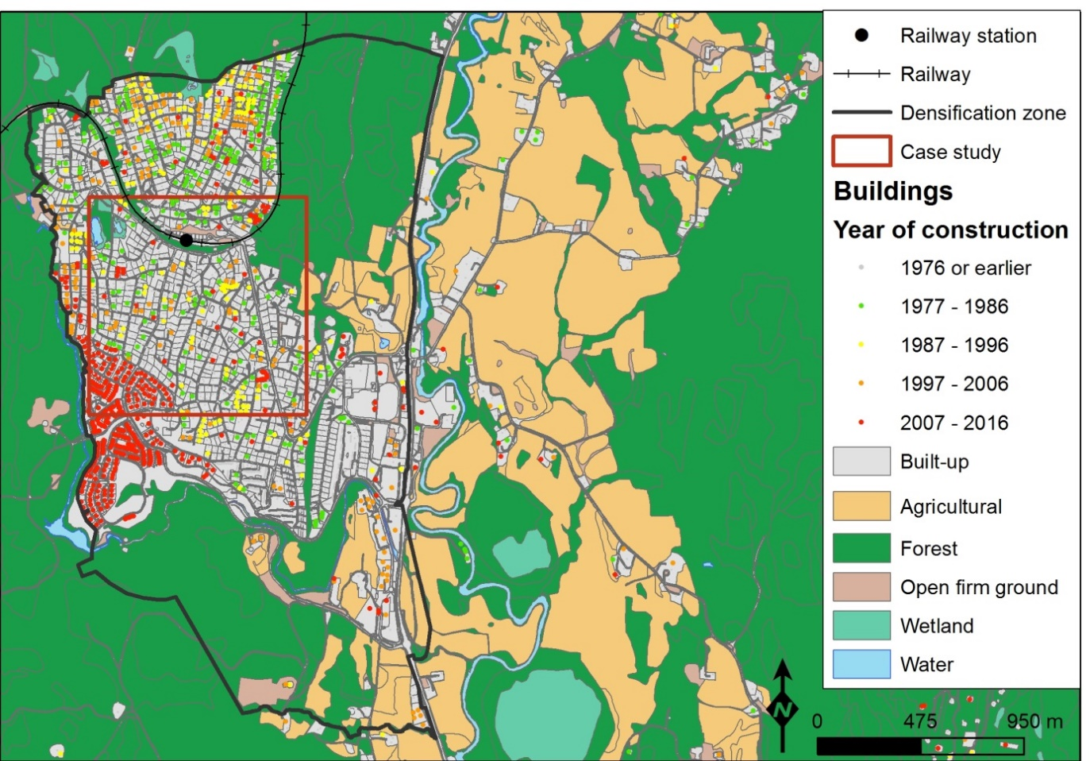

Densification in Nittedal has been considerable during the last twenty years. The main new development has, however, been in the south western part of the municipality, at the area of a previous industrial site, as well as a large development on forest land. A large number of houses have been built in new residential areas with a high density of buildings.

The land use/land cover map A (Fig. A.5) in this case study area provides more information about infrastructure, i.e. the settlement pattern, roads and rivers are clearly indicated. In map C the road map (orthophoto) has been left out, hence there are some additional features that can be identified from the Sentinel-2 data (map C) that clearly shows that the private green dominates the green structure in this case study area. Some water in the Sentinel-2 map has been classified as trees. If this is riparian tree canopy, it is an important ecosystem condition indicator rather than a misclassification.

**Fig. A.4. Nittedal. Comparing the information content of the map of land use/land cover and the map of Sentinel-2 satellite data. 2017**

Fig. A.4 illustrates the differences in information content between the map of land use/land cover and the map of Sentinel-2 satellite data. The statistics show more detailed information from the land use/land cover map as compared to the Sentinel-2 map. Combining with data from Sentinel-2, the developed land, i.e. the red area, with known land use and unknown land cover, can be divided into grass, trees, and open bare ground (driveways and parking lots). Supplementary cadaster information can be included to decide whether the green areas are private or public. The land use/land cover statistics display some grass-fields as well in some limited plots, not being agricultural areas, accordingly this will have to be sports-fields or parkland. This can be decided upon in the more detailed classification of land use.

**Fig. A.5. Case study area: Nittedal. 2017**

|  |  |  |  |
| --- | --- | --- | --- |
| A- Land use/land cover maps | | C- Sentinel-2, NDVI Et bilde som inneholder kart  Beskrivelse som er generert med svært høy visshet | |
| B- Aerial photo  Et bilde som inneholder tog, bro, stående, spor  Beskrivelse som er generert med svært høy visshet | | D- Private and public green | |
| A | C | | D |

*Case study area 5: Årnes in Nes municipality*

Årnes is located quite far from the labor market of Oslo. However, there is still a fair amount of commuting, and hence new houses are being built in the central area close to the railway. Some of the new developments seem to be on prime agricultural land (Fig. A.6 and Fig. A.8, map B), which is surprising, due to policy focus on protection of high-quality agricultural land. Some minor multi-story apartment blocks have been built on the riverbank, with good views and good availability of sunlight. The buyers of these houses are mostly local residents selling their large houses and moving into flats as they still want to live in the municipality.

The densification area contains quite large parcels of agricultural land, and accordingly a policy of using this area for low density housing development will probably not be acceptable. Furthermore, the politicians want to allow new settlements in other small centers in the municipality in order to keep schools and the existing settlement pattern.

Fig. A.6. Årnes. Densification zone and recent development 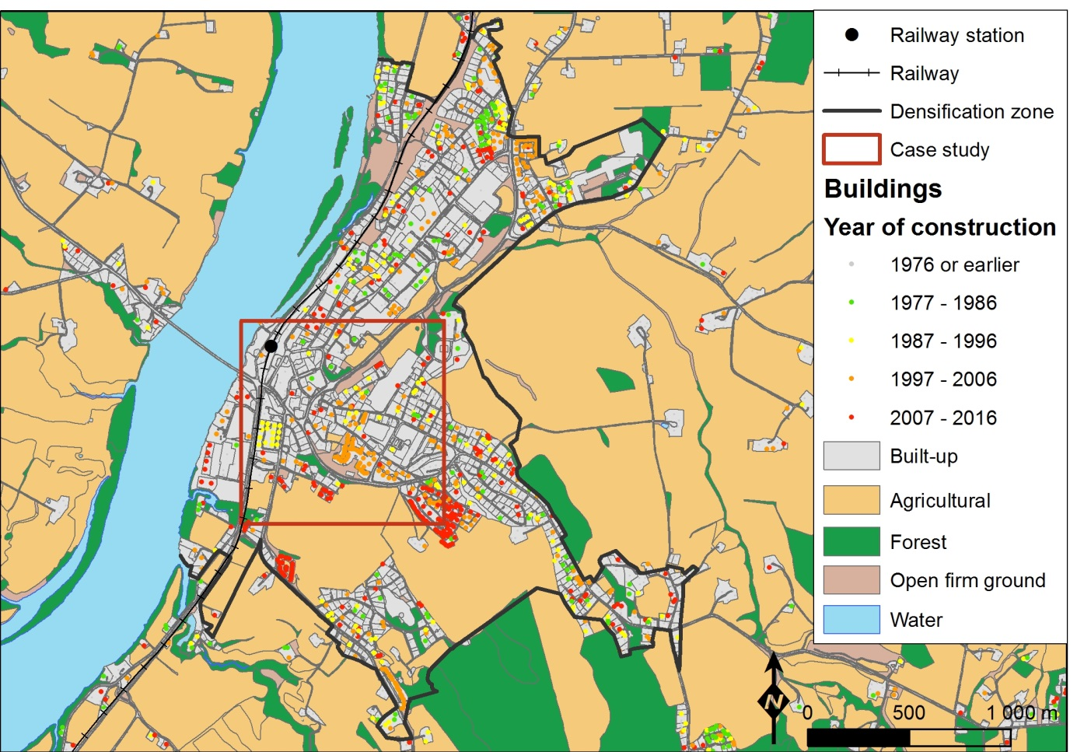

Map A, B, C, D (Fig. A.8) show that Årnes is an old industrial town based on agriculture and forestry. Some of the city structure represents the old factory areas. Thus the lack of green in the old part of the town is noteworthy. Worth noticing is as well the amount of green in the residential areas, with a dominance of private green areas, but with large blocks of public greens along some of the roads (Map D).

Fig. A.7. Årnes. Comparing the information content of the map of land use/land cover and the map of Sentinel-2 satellite data. 2017

Fig. A.7 illustrates the differences in information content between the map of land use/land cover and the map of Sentinel-2 satellite data. The statistics show more detailed information from the land use/land cover map as compared to the Sentinel-2 map. Both sources of information show the large agricultural areas in this rural community.

**Fig. A.8. Case study area: Årnes. 2017**

|  |  |  |  |
| --- | --- | --- | --- |
| A- Land use/land cover maps | | C- Sentinel-2, NDVI and orthophoto Et bilde som inneholder kart  Beskrivelse som er generert med svært høy visshet | |
| B- Aerial photo  Et bilde som inneholder bord  Beskrivelse som er generert med svært høy visshet | | D- Private and public green | |
| A | C | | D |

Fig. A.9. Distribution of green and grey areas, from Sentinel-2, within red areas (known land use, unknown land cover) of the land use/land cover map. Comparison of case study areas. 2017

|  |  |
| --- | --- |
| Karl Johan | Nittedal |
| Akersveien | Årnes |
| Grefsen |  |

1. A key question in ecosystem accounting is the use of Ecosystem Asset (EA) and to what extent they represent statistical spatial units and how they can be linked to other statistical units and spatial information categories. This issue is beyond the scope of this article.
2. Ecotones are areas of steep transition between ecosystems along an environmental or other gradient.
3. In the figure in [8], we have added Modelling, to emphasize the importance of modelling the use of ecosystem services to analyze the capacity for bundles of future ecosystem services.
4. An orthophoto is an aerial photograph or satellite imagery geometrically corrected such that the scale is uniform and the photo corresponds to a given map projection.
5. Adding LiDAR information on height of vegetation will be extremely helpful with detecting vegetation types.
6. In combining the land use/land cover map and Sentinel-2 map, the Sentinel-2 map is no longer in raster form.
7. This approach ensures that sections of pixels located at borders of SSB land use areas are included in the result, which is particularly important for narrow polygons.
8. Map legend is the same in all case study areas, whether or not the actual land use/land cover occurs.