Trophic niche similarity among sea trout Salmo trutta in Central Norway investigated using different time-integrated trophic tracers

J. G. Davidsen^{1*}, R. Knudsen², M. Power³, A. D. Sjursen¹,
L. Rønning¹, K. Hårsaker¹, T. F. Næsje⁴ and J. V. Arnekleiv¹

¹NTNU University Museum, Norwegian University of Science and Technology, NO-7491 Trondheim, Norway.

²Department of Arctic and Marine Biology, The Arctic University of Norway, NO-9037 Tromsø, Norway.

³Department of Biology, University of Waterloo, Waterloo, ON, Canada, N2L 3G1

⁴Norwegian Institute for Nature Research, NO-7485 Trondheim, Norway.

Running headline: Trophic niche similarity among sea trout
Corresponding author(*): Jan Grimsrud Davidsen, NTNU University Museum, Department of Natural History, NO-7491 Trondheim; Norway. Tel.: +47 924 64314; email: jan.davidsen@ntnu.no
Abstract
From 2011-2013, anadromous brown trout Salmo trutta L. (213-730 mm) were collected during or shortly after their marine feeding migration at seven different localities in Central Norway. The mean volume of stomach content (%) of marine fish prey eaten by S. trutta captured in marine waters varied from 34 % to 89 %. There was a high prevalence (67-100 %) for parasite groups potentially transmitted by marine prey fish (i.e. nematodes, cestodes and trematodes) at all sampling sites. There was a significant overlap in the signatures of both δ¹³C and δ¹⁵N in the muscle tissue between the seven groups of S. trutta, however, individual variation within groups was large. A strong positive relationship between δ¹³C and total body length (L_{T}) indicated size-dependent niche selection, with smaller individuals feeding less on marine prey and more on brackish or freshwater invertebrates in the estuary. Short-term gut contents data and trophically transmitted parasites showed that all size groups were feeding on marine fish. However, an increased dependence upon marine prey fish by larger S. trutta was indicated by a strong positive relationship between L_{T} and δ¹⁵N. Similarities in S. trutta feeding and different time-integrated trophic tracers (stable isotopes and parasites) across seven localities investigated supports a general view that S. trutta feed within similar marine trophic niches. The similarity in feeding niche requirements may decrease resilience of S. trutta populations to anthropogenic ecosystem perturbations that reduce the diversity of potential marine prey items.

Key words: Brown trout; feeding ecology; marine migration; niche overlap, stable isotope analyses; stomach contents; trophically transmitted parasites.
Introduction
Anadromous brown trout Salmo trutta L., often termed sea trout, are widely distributed in the coastal waters of Europe (Elliott 1994, Klemetsen et al. 2003). Outside of the natural area for the species (e.g. New Zealand, Kerguelen Islands and Canada) anadromy is similarly observed in introduced S. trutta (Elliott 1994, Lecomte et al. 2013). By exploiting better feeding habitats, migration enables individuals to attain higher growth rates, larger size-at-age, and higher fecundity (Hendry et al. 2004), all of which may confer fitness benefits compared to animals that do not migrate. Migration, however, incurs costs which include the physiological costs of ionoregulatory adjustments for marine habitation and an increased mortality probability, e.g. owing to predation, parasitism and diseases during migration (Gross et al. 1988, Jonsson & Jonsson 1993).
During the last several decades, the abundance of S. trutta has declined markedly in many regions (ICES 2013). As an example, with the exception of northernmost areas, catches in Norwegian rivers have declined by 24–77 % during the last twenty years (Anon. 2015). Recent findings from several other countries (e.g., England, Ireland and Sweden; ICES 2013) indicate similar declines. It has been hypothesised that declines are related to decreased sea survival caused by changes in food supply or increasing infection by the ectoparasitic salmon lice Lepeophtheirus salmonis Krøyer 1838 (ICES 2013, Thorstad et al. 2015).
Anadromous S. trutta growth depends largely on the availability of marine prey (Nall 1930, Wootton 1998). Growth rates increase abruptly when anadromous salmonids move from fresh to salt water (Jonsson 1985), probably because of improved feeding opportunities which more than compensate for increases in the energy costs of ionic regulation (McKay & Gjerde 1985). However, knowledge of the marine feeding ecology of S. trutta is limited (Rikardsen et al. 2006). This is because S. trutta are difficult to catch at sea and most feeding studies are based on small sample sizes (Knutsen et al. 2001). The few studies of S. trutta feeding that exist highlight the dietary use of marine prey, such as small fish and large crustaceans (Grønvik & Klemetsen 1987, Elliot 1997, Knutsen et al. 2001, Rikardsen et al. 2007, Knudsen et al. 2011), and seasonal variability of the diet (Rikardsen et al. 2006). In addition, parasite studies have shown S. trutta to be infected by generalist parasite species transmitted via amphipods or small prey fish such as gadoids and herring (Hemmingsen & Mackenzie 2001, Knudsen et al. 2011). Nonetheless, there is a paucity of information on general life history characteristics of S. trutta (Thorstad et al. 2016), including comparative regional analyses of differences in feeding habits.
In light of limited information on the marine diet of S. trutta, the aim of the present study was to describe marine diets and associated trophic niches of S. trutta populations from Central Norway. Trophic niches were analysed using stomach content analysis (Hyslop 1980) and two different time-integrated trophic tracers: trophically transmitted parasites (Knudsen et al. 1996) and stable isotopes (Michener & Kaufman 2007). The use of both tracers provided indirect measurements of long-term trophic behaviour and resource use, and made it possible to increase sample sizes by analysing marine feeding ecology based on S. trutta captured in the sea and in rivers a short time after re-entry from marine feeding. As marine fish seem to be common prey for anadromous S. trutta, we hypothesised that S. trutta from different populations within a coastal area would have similar marine trophic niches measured using time-integrated tracers (marine parasites and stable isotopes). Further, we hypothesised S. trutta would display generalist diets at the population level, but specialized feeding at the individual level due to size-related feeding preferences.

Methods
Study areas
Salmo trutta was collected from seven different localities in Central Norway from the River Rauma (62.55653N, 7.68825E) in the south to the River Drevja (65.94587N, 13.13526E) in the north (Fig. 1). Localities differed in river catchment area (28–3119 km²), the length of the lower river available to anadromous fish (4.8–42 km), and their distances from the open sea (0–73 km; Table I). One of the seven localities (Agdenes) was not connected to a specific river system and consisted of catches from several local river systems obtained from fish confined to the fjord area with a bag net placed at the mouth of the fjord.

Sampling of Salmo trutta and potential prey
All sampling took place during June-September 2011-2013 (Table I). In total, 258 S. trutta were obtained using different collection methods from seven localities (five rivers/river mouths and two fjords; Fig. 1 and Table I). Based on subsequent δ³⁴S analyses (see isotope analyses description), 40 individuals were defined as resident trout (non-migratory) and were omitted from further analysis.
In River Drevja, River Hundåla and River Rauma, rotenone was previously used to eradicate Gyrodactylus salaris from the watercourses. The aim of the treatment was to kill all carriers of the parasite in the river system. As a part of the programme, dead fish were collected and preserved frozen for future studies. Salmo trutta individuals from these water courses were randomly sampled from the central storage facility maintained by the Norwegian Veterinary Institute and used in the present study. Fish from River Agdenes were captured in two bag nets (mesh sizes 40 and 58 mm) at a research facility located at the mouth of the Trondheim Fjord. In River Nidelva and the River Hopaelva estuary, S. trutta were captured by local game fishers with rod and line, while individuals from the marine Hemnfjord site were captured by gillnets (mesh size 35 mm). Total length (L_{T}, mm) was measured from the tip of the snout to the tip of the longest lobe of the caudal fin without compressing the lobes along the midline andmass (g) was obtained for all individuals. Differences in length and mass of fish between the sampling sites may partly be an artefact of sampling bias introduced by different collection methods.
Potential prey species (e.g. forage fish and benthic invertebrates) were collected from June to September 2012 by trawling, gill netting and individual sampling in the marine Hemnfjord and then frozen. The samples (n=40) included: Gasterosteus aculeatus, Sprattus sprattus, Spinachia spinachia, Myoxocephalus scorpius, Gobiusculus flavescens, Clupea harengus, Scomber scombrus, Pleuronectiformes sp., Macrobrachium lanchesteri, Crangon cragon, Neomysis integer, Gammarus sp., Euphausiacea, Polychaeta and Mysida.

Analyses of stomach contents
A volumetric analysis of stomach contents was conducted following Hyslop (1980). Stomach contents from the upper end of the esophagus to the pyloric sphincter were identified to the lowest practical taxonomic level (typically order or family) under a stereoscopic microscope. For most analyses all orders and families were grouped into “surface insects” or “benthic invertebrates. The relative importance of each prey category was evaluated as volume % for each stomach and the total volume of food category taken by all sampled fish with stomach contents was given as a percentage of the total volume of each stomach content (Hyslop 1980). Gut contents continue to be degraded by stomach acid even if the fish is dead. Consequently, the difference between sampling sites in the ratio of empty stomachs may partly be a result of differences between time of death and gut content sampling at the different locations.

Stable Isotope Analyses
For stable isotope analyses (δ¹³C, δ¹⁵N, δ³⁴S) a sample of dorsal muscle tissue (e.g., Pinnegar & Polunin 1999) was dissected from all S. trutta and frozen until analysed. An exception was done with muscle tissue from Hopaelva estuary which were preserved on 96 % alcohol. Muscle tissue is commonly used to determine long-term diet and in temperate and northern fish typically reflects the summer-period of somatic growth, with the tissue turnover of muscle depending on growth rate (Trueman et al. 2005). For rapidly growing salmonid fishes, the isotopic value of muscle will equilibrate to diet within the order of a few months (Perga & Gerdeaux 2005, Trueman et al. 2005, Phillips & Eldridge 2006). As a consequence, muscle tissue is considered a useful surrogate for the study of temporally integrated feeding in anadromous salmonid fishes (Doucett et al. 1999b, Etheridge et al. 2008, van der Velden et al. 2012), with δ¹³C and δ¹⁵N stable isotope ratios of a consumer reflecting the isotopic signatures of the prey consumed during the time period that the tissue was synthesised (Fry 2006). The δ¹³C signature provides an indication of the origin of the carbon source since littoral, pelagic and profundal carbon sources in freshwater have different δ¹³C signatures, decreasing along littoral-profundal gradients (Van der Zanden & Rasmussen 1999). In the marine environment δ¹³C value of marine carbonates (DIC) tends toward 0‰ with the result that the δ¹³C of resident biota are also elevated (Sharp 2007). In contrast, the δ¹⁵N signature of an organism indicates trophic position, since δ¹⁵N signatures increase with an increase in trophic level (Van der Zanden & Rasmussen 1999, Post 2002). Further, the stable signature ratio of δ³⁴S reflects if individuals have previously been to sea (Doucett et al. 1999a) and coupled with δ¹³C may be used to screen organisms for marine residency.
Here, we sorted captured fish into anadromous and non-anadromous groupings based initially on their δ¹³C value, with all fish having δ¹³C values > -22 ‰ being treated as anadromous given that δ¹³C = -22 ‰ is the lower δ¹³C limit for marine organisms found in central Norwegian coastal waters (Fredriksen 2003). The criterion was considered conservative and likely to result in the inclusion of both anadromous and non-anadromous fish in a single group. Accordingly, fish with δ¹³C values < -22 ‰ were re-analyzed using δ³⁴S to more precisely establish anadromy, with higher δ³⁴S values (>10) being considered indicative of anadromy (Doucett et al. 1999a).
Tissues from both S. trutta and potential prey were dried at 50°C for 24 hours. At the University of Waterloo, Canada, the dried tissue was grounded to a fine powder with a mortar and pestle and analysed for stable isotope ratios (δ¹³C, δ¹⁵N, δ³⁴S) using the methods described in Guiguer et al. (2002), Power et al. (2009) and van der Velden et al. (2012). Analyses for δ¹³C and δ¹⁵N were performed using a Delta Plus Continuous Flow Stable Isotope Ratio Mass Spectrometer (Thermo Finnigan, Bremen, Germany) coupled to a Carlo Erba elemental analyzer (CHNS-O EA1108, Carlo Erba, Milan, Italy). Analysis of δ³⁴S was completed using an Isochrom Continuous Flow Stable Isotope Ratio Mass Spectrometer (GV Instruments, Micromass, Manchester, UK) coupled to a Costech Elemental Analyzer (CNSO 4010, Costech Analytical Technologies Inc., Valencia, USA). Working internal laboratory standards were calibrated against the International Atomic Energy Agency standards CH6 for carbon, N1 and N2 for nitrogen, and SO-5, S1 and S2 for sulphur and were run as controls throughout the analysis to ensure the continued accuracy of all measurements (±0.2 ‰ for carbon, ±0.3 ‰ for nitrogen, and ±0.5 ‰ for sulfur in an organic material). Analytical precision was assessed by mean differences of one in ten duplicate samples, where the mean ± standard deviation was 0.14 ± 0.2 ‰ for δ¹³C and 0.18 ± 0.2 ‰ for δ¹⁵N. All results were expressed in standard δ notation (Perga & Gerdeaux 2005).
The C:N ratios of studied fish were uniformly low (C:N < 4 in 94% of samples), which suggests carbon isotope signatures can be left uncorrected for lipids (e.g., Post et al. 2007, Jardine et al. 2013). Use of this rule is unlikely to bias analytical results as individuals with C:N > 4 were drawn from 6 of the studied populations and from sizes in the range 272-730 mm. Furthermore, as noted by Fagan et al. (2011) arbitrary use of lipid correction is itself questionable given the demonstrated lack of relationship between lipid corrected values and actual measured lipid levels in fish. Given the limited need for lipid correction based on the < 4 rule, the random occurrence of individuals with a high C:N ratio within and among populations and the literature evidence questioning the use of routine lipid correction in fish ecological studies, bulk carbon isotope values used in this study were not lipid corrected.
The need for baseline adjustments was assessed using one-way ANOVA followed by Tukey’s post-hoc honestly significant difference test (e.g., Zar 2009). Such an approach works well if the δ15N values of the assumed primary consumers are near 0‰ (e.g., Hobson et al. 2002, Jennings & Warr 2003,Søreide et al. 2006), as they were here. Stable isotope data (δ15N ) for available lower trophic level (e.g., Amphipoda, Mysida, Mytilus edulis) invertebrates sampled from across the latitudinal range 62.3-63.3oN along the central Norwegian coastal area proximate to the S. trutta sampling sites were not significantly different (ANOVA, F2,30 = 2.566, P = 0.094). Although the tested range encompassed only a portion of the range for which S. trutta samples were available (63.0-65.3oN), the data available for testing did not support use of baseline adjustments for among site comparisons of S. trutta stable isotope data. Accordingly, no adjustments were made.”

Analyses of trophically transmitted parasites
Marine parasites of S. trutta were recorded and enumerated from the available frozen intestine and stomach of individual fish as a standard method. Based on a salmonid study from a northern Norwegian fjord system (see Knudsen et al. 2011), parasites were divided into two groups according to their intermediate host type (MacKenzie & Abaunza 1998): (i) parasites transmitted by gammarids, such as the acanthocephalan Echinorhyncus gadi (Zoega, 1776), and (ii) parasites transmitted mainly by marine fish, such as trematodes (e.g., Lecithaster gibbosus Rudolphi, 1802 and Derogenes varicus Müller, 1784), and several nematode species and adult cestodes (Eubothrium sp. Nybelin, 1922). The terms ‘prevalence’ (i.e. the proportion of infected hosts) and ‘abundance’ (i.e. the mean number of parasites in both infected and uninfected hosts) sensu Bush et al. (1997) were used here to describe parasite occurrences in the S. trutta.

Data analyses
Prey δ15N and δ13C signatures were corrected for trophic enrichment (Δ) using, respectively, mean fractionation factors of 3.23 and 1.03, and are presented as post-fractionation equivalents (plotted prey δ values = prey isotope values + Δ) when compared or plotted with S. trutta stable isotope values (e.g., Jensen et al. 2012).
To study isotopic niche widths the SIBER package (Stable Isotope Bayesian Ellipses in R, version 2.0.3, Jackson & Parnell 2016) was used. Preservation of muscle tissue on 96 % alcohol may influence δ¹⁵N and δ¹³C signatures and confound correlations with signatures from frozen material (Stallings et al. 2015). Consequently, the samples from Hopaelva estuary were omitted from the analyses of isotopic niche widths.
To analyse if either δ¹³C or δ¹⁵N were dependent on the total body length (L_{T}) of the fish, a general linear model (GLM) with a Gaussian error distribution and identity link function were used. Collection site was included as a grouping variable to compare the strength of ontogenetic shifts among populations. Possible relationship between (L_{T}) and the tendency to be piscivorous was tested by a binomial logistic regression model using the logit link. All statistical analyses were conducted using RStudio version 1.0.44 (www.rstudio.com).

RESULTS
From the sample of 258 S. trutta from the seven locations (Fig. 1), 218 individuals (213-730mm, Table II) were identified as being anadromous with the use of stable isotope data. The samples from River Rauma had the largest mean L_{T} and mass (599 mm, 2292 g), while S. trutta with the smallest mean L_{T} and mass were from River Drevja samples (313 mm, 364 g).

Stomach contents
Salmo trutta captured in marine waters (Agdenes, Hemnfjord and Hopaelva estuary) in general had higher amounts of marine fish in their stomachs than individuals sampled in the rivers. The mean volume (%) of prey fish in individuals captured in the Hopaelva estuary and in the Agdenes bag nets in the fjord equalled 89 % (Fig. 2). Marine-captured S. trutta from Hemnfjord averaged 34 %, while individuals sampled in the rivers after the marine feeding migration never had more than 18 % fish content in the stomach. Instead, most of the identified stomach contents consisted of benthic invertebrates and surface insects (Fig. 2). Identified marine fish prey consisted of the pelagic fish species sprat S. sprattus L., herring C. harengus L. and small sandeel Ammodytes tobianus L. The proportion of empty stomachs (Table 2) ranged from 21 % (River Rauma, n = 14) to 100 % (River Nidelva, n = 6).
The prey fish described above, were found in the stomach contents of all three size groups (Fig. 3), and there was no increase in the percent fish content by size (r² = 0.004, n = 70, P > 0.05). Surface insects were found in all length classes, and there was no correlation between percent volume and size of the S. trutta (r² = 0.0006, n = 70, P > 0.05). Gammarus spp. were found only in fish >300 mm.

Stable isotope signatures

There was a large overlap in the SIBER ellipses between S. trutta from the seven localities (Fig. 4), with a number of the ellipses for populations being wholly contained in the ellipses of other populations. In total, 90 % of the S. trutta had values within the ranges, respectively, for δ ¹³C and δ ¹⁵N of -18.7 to -25.2 and 7.9 to 14.5. The δ¹³C and δ ¹⁵N signatures from S. trutta and their potential prey in the marine Hemnfjord indicated that they mainly had been feeding on krill and pelagic marine fishes (Fig. 5).
Overall, there was an increase in the δ ¹³C signature (GLM, n = 197, F = 36.179, P < 0.001) and δ ¹⁵N signature (n = 197, F = 94.102, P < 0.001) with increasing fish length ( L_{T}). The strength of the correlation differed between collection sites (δ ¹³C signature: n = 7, F = 9.843, P < 0.001; δ ¹⁵N signature: n = 7, F = 33.609, P = 0.002). Salmo trutta from Agdenes and River Rauma did not show any relationship between δ ¹³C and L_{T} (Agdenes: n = 37, F = 2.763, P = 0.11; River Rauma: n = 14, F = 0.491, P > 0.05), while S. trutta from River Drevja and River Nidelva did not show any relationship between δ ¹³C or δ¹⁵N signatures and L_{T} (δ ¹³C : Drevja: n = 28, F = , P > 0.05; Nidelva: n = 6, F = 0.759, P > 0.05 and δ ¹⁵N: Drevja: n = 28, F = 0.592, P > 0.05; Nidelva: n = 6, F = 4.609, P > 0.05).

Composition of trophically transmitted parasites
For the parasite groups potentially transmitted by marine fish as prey there was a high prevalence (67-100 %) at all sampling sites, both for S. trutta caught in the river and in the sea (Table III). Cestodes, mainly marine Eubothrium sp., were the most prevalent (45-92 %). Trematodes varied more (8-80 %) and nematodes ranged from no infection (river samples from Rauma) up to 54 % (marine sampling at Agdenes). The abundance of parasite groups potentially transmitted by fish was low to intermediate and varied from 1.8 (river sampling in River Hundåla) up to 13.3 (marine sampling at Hopaelva estuary). However, there were no differences in levels of prevalence (t-test; n = 8; P > 0.05) or abundance (n = 8; P > 0.05) between individuals captured in marine water or freshwater. The infection level of Acanthocephala, which have marine crustaceans as an intermediate host, was generally low as indicated by prevalence (highest 15 % in River Drevja sampling) and abundance (highest 1.4 in marine samples from Hemne). The smallest piscivorous S. trutta was 213 mm based on the abundance of parasite groups potentially transmitted by fish. There was no relationship between L_{T} and the tendency to be a piscivore (Logistic regression, n = 156; P > 0.05) based on stomach content or trophically transmitted parasites.

DISCUSSION
The study documented regional similarity of S. trutta population marine trophic niches as measured by stable isotope and marine parasite tracers along a 400 km coastal area of central Norway. Stomach contents from individuals that were caught in marine water consisted mainly of marine fish, while the stomachs of individuals captured in the rivers had higher abundances of benthic invertebrates and surface insects. The abundance and prevalence of parasite groups potentially transmitted by marine fish did not differ between individuals captured in marine water or in the rivers, indicating that S. trutta captured in the river had also been mainly feeding on marine fish sometime prior to their capture. Likewise, stable isotope analyses confirmed similar resource utilisation across the sea-migratory populations. Our study indicated a diverse, habitat-specific diet of S. trutta which concurs with earlier characterisations of S. trutta as an opportunistic feeder (Pemberton 1976, Knutsen et al. 2001, Rikardsen et al. 2006), although there is an apparent preference and reliance on smaller pelagic fishes during their marine feeding migration.
Analyses of stomach contents showed that S. trutta feed on a variety of prey items, but fish were the dominant prey found in individuals captured in marine waters (Agdenes, Hemnfjord and Hopaelva estuary). Reliance on fish as prey has also been documented in earlier studies of S. trutta diets (Grønvik & Klemetsen 1987, Knutsen et al. 2001, Knudsen et al. 2011), and for other coastal feeding anadromous salmonids such as Arctic charr Salvelinus alpinus (L.) (Klemetsen et al. 2003, Rikardsen & Dempson 2011) and Atlantic salmon Salmo salar (Renkawitz et al. 2015). The occurrence of surface insects and benthic invertebrates in stomachs from S. trutta sampled in the rivers after the marine feeding migration indicates that these S. trutta also feed in the river mouth or in river after returning from the sea.
Stable isotope analysis of muscle tissue from the S. trutta in this study revealed a broad range of signatures for both δ¹³C and δ¹⁵N, although the values tended toward the higher values indicative of marine feeding (e.g., Doucett et al. 1999a, Etheridge et al. 2008). The range of δ¹³C indicates that the S. trutta have a mixed feeding strategy, with comparison of stable isotope signatures from S. trutta and their potential prey in Hemnfjord indicating mixed feeding on krill, pelagic and littoral fishes. Individuals with δ¹³C values in the range -21 to -22 may only have fed for a short time in the marine habitat or may have mainly preyed upon brackish or freshwater invertebrates in the estuary (Etheridge et al. 2008). While the majority of stable isotope signatures are consistent with marine feeding, differences were evident in the stomach content analyses among sites. These results suggest rapid transition from fish to invertebrate prey as S. trutta re-enter freshwater. Lags in tissue turnover in salmonids are typically on the order of months (Trueman et al. 2005), implying that despite evidence of recent freshwater feeding and residency, the majority of piscivorous S. trutta sampled in this study fed in the marine environment.
The observed relationship between L_{T} and δ¹⁵N is indicative of size-dependent feeding strategies, with smaller S. trutta feeding on a mixture of invertebrate and fish prey in estuaries and larger S. trutta feeding mainly on marine prey. Accordingly, there are ontogenetic shifts in prey selection (e.g., Guiguer et al. 2002, van der Velden et al. 2012), with larger individuals feeding at higher trophic levels because of increased forage fish consumption. That no such relationship was found in the S. trutta from River Drevja and River Nidelva is likely due to the low mean length (Drevja) and low number of sampled fish (Nidelva).
Marine parasites were frequent (67-100 %) on S. trutta at all sampled localities, and infection patterns (prevalence and abundance) showed consistency across different habitat types (i.e., fjords and river systems) across the entire geographic region. Parasite species potentially transmitted by fish as prey (i.e. nematodes, cestodes and trematodes) had a much higher prevalence than parasites transmitted by crustaceans (i.e., Acanthocephala), which may be because fish are the main dietary component of S. trutta. Also, S. trutta caught in the sea had similar patterns of infection to those individuals caught in the river, suggesting that prevalence of marine parasitesis a good indicator of anadromous life-history strategies in general, both at the individual (Knudsen et al. 2011, Knudsen et al. 2014) and the population level (e.g. MacKenzie & Abaunza 1998, Knudsen et al. 2005).
Generally, the endo-parasites recorded from Central Norwegian S. trutta had lower abundance compared to north Norway (Knudsen et al. 2011). Parasite infections have been shown to impair swimming performance, and lead to decreases in burst swimming speed, migration performance, and fatigue distance (Barber & Poulin 2002). High parasite burdens have also been associated with pale gills, decreased body condition and host mortality in farmed S. trutta (Rubio-Godoy & Tinsley 2008), with high loads of intestinal helminths in particular seen as the probable trigger for long-term malnutrition leading to increased S. trutta emaciation and mortality (Mladineo et al. 2009). High parasite loads may also affect fish behaviour, altering habitat use and foraging opportunity as infected individuals adopt movement patterns expected to suppress infestation rates (Gjelland et al. 2014). Lowered levels of parasites observed at sites sample heresuggest reduced parasite-induced energetic and fitness costs for S. trutta in central Norway. A possible exception may be those individuals that had relatively high densities of the adult cestode, Eubothrium sp. This genus has been shown to have negative consequences for individuals somatic growth (Bristow & Berland 1991, Saksvik et al. 2001).
Examination of stomach contents indicated that small pelagic fish species like sprat S. sprattus, herring C. harengus and small sandeel A. tobianus are important parts of S. trutta diets, as has been similarly noted in the studies of Knutsen et al. (2001) and Rikardsen & Amundsen (2005). Observed trophic niche similarity across sea trout populations over a large geographical area suggests that sea-trout may be vulnerable to fluctuations in these prey populations.
In partially anadromous species, marine migrations are not obligate and individual fish may change life history tactics (i.e. anadromy versus freshwater residency) to maximize fitness if environmental conditions change (e.g., Nordeng 1983, Jonsson & Jonsson 1993). Indeed, anadromy may have evolved in the first place as a response to situations where food resources in the sea exceeded those in freshwater (Gross 1987). Thus, significant decreases in biomass and reduced availability of pelagic prey fish species for larger S. trutta may trigger alterations in their feeding behaviour by reduced feeding time at sea and/or shifting diet to a heavier reliance on littoral marine or even a change in life history tactics to fed exclusive on freshwater prey resources.
Other preferred dietary items in addition to the species mentioned above may include fishes of the families Clupeidae and Gobiidae in areas and years when they are abundant (Knutsen et al. 2001, Knutsen et al. 2004) but these were not observed here.Prey fish species found in this study, have generally been subject to wide fluctuations in relative abundance. For example, the biomass of A. tobianus has declined markedly in the last two decades (ICES 2015). Likewise, C. harengus experienced significant decline in abundance in the 1970s (ICES 2015). Fluctuations in relative abundances of small prey fishes have been correlated with size (mass) of other coastal feeding salmonids such as S. alpinus (Dempson et al. 2002).
Similarities of marine-captured S. trutta diets and stable isotope signatures and the pattern of infection of marine parasites suggests that there was rough equivalence in the foraging niches across S. trutta populations along the coastal area of Central Norway. Results thus indicate that the marine environment in the actual geographical region has relatively similar diet resources for anadromous salmonid populations. The geographic equivalence of the trophic niche of anadromous S. trutta could imply that they are vulnerable to possible future changes in the coastal environments that would affect the densities of favoured marine prey. Thus, the variable density of the marine prey fish species used by S. trutta along the coast could explain some of the declines in the recorded densities of sea trout populations that have been observed in recent decades (ICES 2013, Anon. 2015). As S. trutta in general appear to depend on pelagic fish species such as S. sprattus, C. harengus and A. tobianus, special attention needs to be given to the conservation of these species as they represent important prey resources for S. trutta.
In conclusion, the large similarity observed in S. trutta feeding niches from the seven localities found using stomach contents combined with two different time-integrated trophic tracers (trophically transmitted parasites and stable isotopes) suggests S. trutta occupy similar trophic niches at broad regional scales. While it was found that the S. trutta had generalist diets at the population level, as individuals they tend to specialize due to size-related feeding preferences. Such specialization may decrease the resilience, and abundance, of S. trutta to anthropogenic ecosystem perturbations (e.g. climate change, overfishing, shoreline development) that may change the diversity of potential marine prey items.

ACKNOWLEDGEMENT
This study was financed by the County Governor of Sør-Trøndelag, The Royal Norwegian Society of Sciences and Letters, the Norwegian Institute for Nature Research, UiT the Arctic University of Norway, an NSERC Discovery Grant to MP and the NTNU University Museum. M. G. Hansen, A. Jørrestol, S. H. Eldøy and A. Sandvik are thanked for their extensive help during the fieldwork and G. Kjærstad for assistance with analysis of the fish. M. Daverdin at the NTNU University Museum is thanked for drawing the map and A. Eloranta for comments on a previous version of the manuscript.

References
Anon. (2015) Status of Norwegian salmon populations in 2014. Norwegian Scientific Advisory Committee for Atlantic Salmon Management. In, http://www.nina.no/archive/nina/PppBasePdf/Rapp%20Vitr%C3%A5dlaks/Thorstad%20Status%20RVitr%C3%A5d%20laks2015-8.pdf
Barber I, Poulin R (2002) 2002 Interactions between fish, parasites and disease. In: Hart PJB, Reynolds JD (eds) Handbook of Fish Biology and Fisheries, Book 1. Blackwell Publishing, Oxford, U.K
Bristow GA, Berland B (1991) The effect of long term, low level Eubothrium sp. (Cestoda: Pseudophyllidea) infection on growth in farmed salmon (Salmo salar L.). Aquaculture 98:325-330
Bush AO, Lafferty KD, Lotz JM, Shostak AW (1997) Parasitology meets ecology on its own terms: Margolis et al. revisited. J Parasitol 83:575-583
Dempson JB, Shears M, Bloom M (2002) Spatial and temporal variability in the diet of anadromous Arctic charr, Salvelinus alpinus, in northern Labrador. Environ Biol Fishes 64:49-62
Doucett RR, Hooper W, Power G (1999a) Identification of anadromous and non-anadromous adult brook trout (Salvelinus fontinalis) and their progeny in the Tabusintac River, New Brunswick, using multiple stable-isotope analysis. Trans Am Fish Soc 128:278-288
Doucett RR, Power M, Power G, Caron F, Reist JD (1999b) Evidence for anadromy in a southern relict population of Arctic char from North America. J Fish Biol 55:84-92
Elliot JA (1997) Stomach contents of adult sea trout caught in six English rivers. J Fish Biol 50:1129–1132
Elliott JM (1994) Quantitative ecology and the brown trout, Vol. Oxford University Press, Oxford
Etheridge EC, Harrod C, Bean C, Adams CE (2008) Continuous variation in the pattern of marine v. freshwater foraging in brown trout Salmo trutta L. from Loch Lomond, Scotland. J Fish Biol 73:44-53
Fagan K-A, Koops MA, Arts MT, Power M (2011) Assessing the utility of C:N ratios for predicting lipid content in fishes. Can J Fish Aquat Sci 68:374-385
Fredriksen S (2003) Food web studies in a Norwegian kelp forest based on stable isotope (δ¹³C and δ¹⁵N ) analysis. Mar Ecol Prog Ser 26:71-81
Fry B (2006) Stable Isotope Ecology, Vol. Springer, New Yourk, NY
Gjelland KØ, Serra-Llinares RM, Hedger RD, Arechavala-Lopez P, Nilsen R, Finstad B, Uglem I, Skilbrei OT, Bjørn PA (2014) Effects of salmon lice infection on the behaviour of sea trout in the marine phase. Aquac Environ Interact 5:221-233
Gross MR (1987) Evolution of diadromy in fishes. In: Dadswell MJ, Klauda RJ, Moffitt CM, Saunders RL, Rulifson RA, Cooper JE (eds) Common Strategies of Anadromous and Catadromous Fishes, Book 1. American Fisheries Society Symposium 1, Bethesda
Gross MR, Coleman RM, McDowall RM (1988) Aquatic productivity and the evolution of diadromous fish migration. Science 239:1291-1293
Grønvik S, Klemetsen A (1987) Marine food and diet overlap of Co-occuring Arctic charr (Salvelinus alpinus L.), Brown trout (Salmo trutta L.) and Atlantic salmon (S. salar L.) off Senja, N. Norway. Polar Biol 7:173-177
Guiguer KRRA, Reist JD, Power M, Babaluk JA (2002) Using stable isotopes to confirm the trophic ecology of Arctic charr morphotypes from Lake Hazen, Nunavut, Canada. J Fish Biol 60:348-362
Haukås M, Hylland K, Nygård T, Berge JA, Mariussen E (2010) Diastereomer-specific bioaccumulation of hexabromocyclododecane (HBCD) in a coastal food web, Western Norway. Sci Total Environ 408:5910-5916
Hemmingsen W, Mackenzie K (2001) The parasite fauna of the cod, Gadus morhua L. Adv Mar Biol 40:1-80
Hendry AP, Bohlin T, Jonsson B, Berg OK (2004) To sea or not to sea? Anadromy versus non-anadromy in salmonids. In: Hendry AP, Stearns SC (eds) Evolution Illuminated: Salmon and Their Relatives. Oxford University Press, New York, NY. USA
Hobson KA, Fisk A, Karnovsky N, Holst M, Gagnon J-M, Fortier M (2002) A stable isotope (d13C, d15N) model for the North Water food web: implications for evaluating trophodynamics and the flow of energy and contaminants. Deep-Sea Research II 49:5131-5150
Hyslop EJ (1980) Stomach contents analysis - a review of methods and their application. J Fish Biol 17:411-429
ICES (2013) Report of the Workshop on Sea Trout (WKTRUTTA), 12–14 November 2013, ICES Headquarters, Copenhagen, Denmark. In:
ICES (2015) ICES Stock Assesment database. In. ICES, Copenhagen
Jackson AL, Parnell AC (2016) Stable Isotope Bayesian Ellipses in R. In, https://cran.r-project.org/web/packages/SIBER/SIBER.pdf
Jardine TD, Hunt RJ, Faggotter SJ, Valdez D, Burford MA, Bunn SE (2013) Carbon from periphyton supports fish biomass in waterholes of a wet-dry tropical river. River Res Appl 29:560-573
Jennings S, Warr KW (2003) Environmental correlates of large-scale spatial variation in the d15N in marine animals. Mar Biol 142:1131-1140
Jensen H, Kiljunen M, Amundsen P-A (2012) Dietary ontogeny and niche shift to piscivory in lacustrine brown trout Salmo trutta revealed by stomach content and stable isotope analyses. J Fish Biol 80:2448-2462
Jonsson B (1985) Life history patterns of freshwater resident and sea-run migrant brown trout in Norway. Trans Am Fish Soc 114:182-194
Jonsson B, Jonsson N (1993) Partial migration: niche shift versus sexual maturation in fishes. Rev Fish Biol Fish 3:348-365
Klemetsen A, Amundsen P-A, Dempson JB, Jonsson B, Jonsson N, O´Connell MF, Mortensen E (2003) Atlantic salmon Salmo salar L., brown trout Salmo trutta L., and Arctic charr Salvelinus alpinus (L.): a review of aspects of their life histories. Ecol Freshwat Fish 12:1-59
Knudsen R, Amundsen PA, Rikardsen AH (2011) Individual feeding specialisation of a naïve vs. veteran predators. Ecol Freshwat Fish 20:522-528
Knudsen R, Klemetsen A, Staldvik F (1996) Parasites as indicators of individuel feeding specialization in Arctic charr during winter in northern Norway. J Fish Biol 48:1256-1265
Knudsen R, Rikardsen AH, Dempson JB, Bjørn PA, Finstad B, Holm M, Amundsen PA (2005) Trophically transmitted parasites in wild Atlantic salmon post-smolts from Norwegian fjords. J Fish Biol 66:758-772
Knudsen R, Siwertsson A, Adams CE, Newton J, Amundsen P-A (2014) Similar patterns of individual niche use are revealed by different time-integrated trophic tracers (stable isotopes and parasites). Ecol Freshwat Fish 23:259–268
Knutsen JA, Knutsen H, Gjøsæter J, Jonsson B (2001) Food of anadromous brown trout at sea. J Fish Biol 59:533-543
Knutsen JA, Knutsen H, Olsen EM, Jonsson B (2004) Marine feeding of anadromous brown trout (Salmo trutta L.) during winter. J Fish Biol 64:89-99
Lecomte F, Beall E, Chat J, Davaine P, Gaudin P (2013) The complete history of salmonid introductions in the Kerguelen Islands, Southern Ocean. Polar Biol 36:457-475
MacKenzie K, Abaunza P (1998) Parasites as biological tags for stock discrimination of marine fish: a guide to procedures and methods. Fish Res 38:45-56
McKay LR, Gjerde B (1985) The effect of salinity on growth of rainbow trout. Aquaculture 49:325-331
Michener RH, Kaufman L (2007) Stable isotope ratios as tracers in marine food webs: an update. In: Michener RH, Lajtha K (eds) Stable isotopes in Ecology and environmental science. Blackwell, Malden, MA
Mladineo I, Zrnčić Z, Oraić D (2009) Severe helminthic infection of the wild brown trout (Salmo trutta) in Cetina River, Croatia; Preliminary observation. Bull Eur Assoc Fish Pathol 29:86-91
Nall GH (1930) The life of the sea trout, Vol. Seeley, Service and Co., London
Nordeng H (1983) Solution to the "char problem" based on Arctic char (Salvelinus alpinus) in Norway. Can J Fish Aquat Sci 40:1372-1387
Pemberton R (1976) Sea trout in North Argyll sea lochs. 2. Diet. J Fish Biol 9:195-208
Perga ME, Gerdeaux D (2005) Are fish what they eat´all year around? Oecologia 144:598-606
Phillips DL, Eldridge PM (2006) Estimating the timing of diet shifts using stable isotopes. Oecologia 147:195-203
Pinnegar JK, Polunin NVC (1999) Differential fractionation of δ13C and δ15N among fish tissues: implications for the study of trophic interactions. Funct Ecol 13:225-231
Post DM (2002) Using stable isotopes to estimate trophic position: models, methods, and assumptions. Ecology 83:703-718
Post DM, Layman CA, Arrington DA, Takimoto G, Quattrochi J, Montana CG (2007) Getting to the fat of the matter: Models, methods and assumptions for dealing with lipids in stable isotope analyses. Oecologia 152:179-189
Power M, Power G, Reist JD, Bajno R (2009) Ecological and genetic differentiation among the Arctic charr of Lake Aigneau, Northern Qubec. Ecol Freshwat Fish 18:445-460
Renkawitz MD, Sheehan TF, Dixon HJ, Nygaard R (2015) Atlantic salmon (Salmo salar) feeding ecology and energy acquisition at West Greenland. Mar Ecol Prog Ser 538:197–211
Rikardsen AH, Amundsen PA (2005) Pelagic marine feeding of Arctic charr and sea trout. J Fish Biol 66:1163-1166
Rikardsen AH, Amundsen PA, Knudsen R, Sandring S (2006) Seasonal marine feeding and body condition of sea trout (Salmo trutta) at its northern distribution. ICES J Mar Sci 63:466-475
Rikardsen AH, Dempson J (2011) Dietary life-support: the food and feeding of Atlantic salmon at sea. In: Aas Ø, Einum S, Klemetsen A, Skurdal J (eds) Atlantic Salmon Ecology Wiley-Blackwell, New York
Rikardsen AH, Dempson JB, Amundsen P-A, Bjørn PA, Finstad B, Jensen AJ (2007) Temporal variability in marine feeding of sympatric Arctic charr and sea trout. J Fish Biol 70:837-847
Rubio-Godoy M, Tinsley RC (2008) Recruitment and effects of Discocotyle sagittata (Monogenea) infection on farmed trout. Aquaculture 274:15-23
Saksvik M, Nilsen F, Nylund A, Berland B (2001) Effect of marine Eubothrium sp. (Cestoda: Psaudophyllidea) on growth of Atlantic salmon, Salmo salar L. J Fish Dis 24:111-119
Sharp Z (2007) Principles of Stable Isotope Geochemistry, Vol. Pearson Prentice-Halll, Upper Saddle River, NJ
Stallings CD, Nelson JA, Rozar KL, Adams CS, Wall KR, Switzer TS, Winner BL, Hollander DJ (2015) Effects of preservation methods of muscle tissue from upper-trophic level reef fishes on stable isotope values (δ13C and δ15N). PeerJ 3:e874
Søreide JE, Hop H, Carroll ML, Falk-Petersen S, Hegseth EN (2006) Seasonal food web structures and sympagic–pelagic coupling in the European Arctic revealed by stable isotopes and a two-source food web model. Prog Oceanogr 71:59-87
Thorstad EB, Todd CD, Uglem I, Bjorn PA, Gargan PG, Vollset KW, Halttunen E, Kålås S, Berg M, Finstad B (2016) Marine life of the sea trout. Mar Biol 163: 47
Thorstad EB, Todd CD, Uglem I, Bjørn PA, Gargan PG, Vollset KW, Halttunen E, Kålås S, Berg M, Finstad B (2015) Effects of salmon lice Lepeophtheirus salmonis on wild sea trout Salmo trutta—a literature review. Aquac Environ Interact 7:91–113
Trueman CN, McGill RAR, Guyard PH (2005) The effect of growth rate on tissue-diet isotopic spacing in rapidly growing animals. An experimental study with Atlantic salmon (Salmo salar). Rapid Communications in Mass Spectrometry 19:3239-3247
van der Velden S, Reist JD, Babaluk JA, Power M (2012) Biological and life-history factors affecting total mercury concentrations in Arctic charr from Heintzelman Lake, Ellesmere Island, Nunavut. Sci Total Environ 433:309-317
Van der Zanden MJ, Rasmussen JB (1999) Primary consumer δ13C and δ15N and the trophic position of aquatic consumers. Ecology 80:1395-1404
Wootton RJ (1998) Ecology of teleost fishes, Vol. Kluwer Academic, Dordrecht
Zar JH (2009) Biostatistical analysis, Vol. Pearson, New York

Table I. Overview of study S. trutta sampling locations, 2011-2013.
Location | Catchment area (km²) | Length of anadromous stretch (km) | Distance to  open sea (km) | Sampling Place (freshwater / marine water) | Sampling Time | Sampling Method
River Drevja | 178 | 25 | 67 | River | Aug 2011 |  | Rotenone
River Hundåla | 39 | 6 | 58 | River | Aug 2011 |  | Rotenone
River Nidelva | 3119 | 8 | 73 | River | Jun–Sep 2011/2012 |  | Rod and line
Agdenes | NA | NA | 0 | Marine | Jun–Aug 2012 |  | Bag net
Hemnfjord | NA | NA | 30 | Marine | Jun–Sep 2012 |  | Gillnet
Hopaelva estuary | 28 | 10 | 4 | Estuary | Jul–Sep 2012 |  | Fly fishing
River Rauma | 1240 | 42 | 72 | River | Aug 2013 |  | Rotenone
NA = no available information

Table II. Number of sampled anadromous S. trutta (n), total body length (L_{T}, mm), mass (g) and proportion of empty stomachs from seven study sampling localities in Central Norway
Location | n | Mean length (s.d.) | Range | Mean mass (s.d.) | Range | Proportion of empty stomachs (%)
River Drevja | 28 | 316 (62) | 218 - 442 | 364 (196) | 117 - 817 | 82
River Hundåla | 80 | 367 (80) | 213 - 583 | 553 (352) | 120 - 1970 | 81
River Nidelva | 6 (4*) | 522 (167) | 347 - 730 | 1817 (1808) | 356 - 4200 | 100
Agdenes | 37 | 433 (77) | 346 - 660 | 966 (662) | 427 - 3150 | 76
Hemnfjord | 32 | 356 (72) | 235 - 495 | 475 (252) | 130 - 1184 | 50
Hopaelva estuary | 21 | 369 (85) | 262 - 600 | 606 (367) | 186 - 1700 | 33
River Rauma | 14 | 599 (82) | 485 - 730 | 2292 (893) | 1077 - 4030 | 21
*=number of fish used in calculation of mass

Table III. Infection (Pr=prevalence; Ab=abundance) of marine parasites in study S. trutta caught in riverine (R) and marine (M) environments. Fish-par denotes combined parasite groups (Nematodes, Cestodes and Trematodes) that can be potentially transmitted by fish as prey.
 |  |  | Achanthocephala |  | Nematodes |  | Cestodes |  | Trematodes |  | Fish-par
Locality | Habitat | n | Pr | Ab | Pr | Ab | Pr | Ab | Pr | Ab | Pr | Ab
Drevja | R | 20 | 15.0 | 0.7 | 35 | 2.5 | 45.0 | 1.3 | 20.0 | 0.4 | 85.0 | 4.2
Hundåla | R | 44 | 4.6 | 0.1 | 15.9 | 0.2 | 63.6 | 1.1 | 29.5 | 0.5 | 77.3 | 1.8
Nidelva | R | 3 | 0.0 | 0.0 | 0.0 | 0.0 | 66.7 | 5.0 | 33.3 | 2.3 | 66.7 | 7.3
Rauma | R | 12 | 0.0 | 0.0 | 0.0 | 0.0 | 91.7 | 8.8 | 8.3 | 0.3 | 100 | 9.1
Agdenes | M | 28 | 3.6 | 0.4 | 53.6 | 1.8 | 50.0 | 1.0 | 35.7 | 0.9 | 75.0 | 3.7
Hemne | M | 29 | 3.5 | 1.4 | 34.9 | 0.7 | 58.6 | 2.6 | 17.2 | 1.1 | 79.3 | 4.4
Hopaelva | M | 20 | 0.0 | 0.0 | 25.0 | 0.6 | 85.0 | 3.4 | 80.0 | 9.3 | 100 | 13.3

Figure captions:

Figure 1: Location of study S. trutta sampling sites (2011-2013).

Figure 2: Prey species composition in stomach contents of S. trutta taken from six different localities in Central Norway. Benthic invertebrates: Plecoptera, Trichoptera, Simulidae, Chironomidae, Megaloptera, Hydracarina, Oligochaeta, Lymnidae, Planorbidae, Nematoda, Odonata. Surface insects include all stages (larvae, pupea, adult) of insects from the terrestrial environment and aquatic adult insects with an aerial life stage. Water rat: Arvicola amphibiu. In River Nidelva (not shown) all sampled stomachs were empty.

Figure 3: Prey species composition in stomach contents of S. trutta taken from six localities in Central Norway. In River Nidelva (not shown) all sampled stomachs were empty. Benthic invertebrates: Plecoptera, Trichoptera, Simulidae, Chironomidae, Megaloptera, Hydracarina, Oligochaeta, Lymnidae, Planorbidae, Nematoda, Odonata. Surface insects include all stages (larvae, pupea, adult) of insects from the terrestrial environment and aquatic adult insects with an aerial life stage. Water rat: Arvicola amphibiu.

Figure 4: Standard ellipse area (SEAc) for S. trutta from six different localities in Central Norway. Black colour: River Drevja; red: River Hundåla; green: River Nidelva; dark blue: Agdenes; light blue: Hemnfjord; pink: River Rauma.

Figure 5: Stable isotope signatures of . trutta (▲) from Hemnfjord in Central Norway. Signatures of potential prey are presented (×= littoral marine fish; ◊ = pelagic marine fish; + = krill; • = bristle worm; ∆ = shrimp). Note prey -isotope signatures have been corrected for fractionation and as plotted are the post fractionation values (e.g. measured isotope value + fractionation factor).

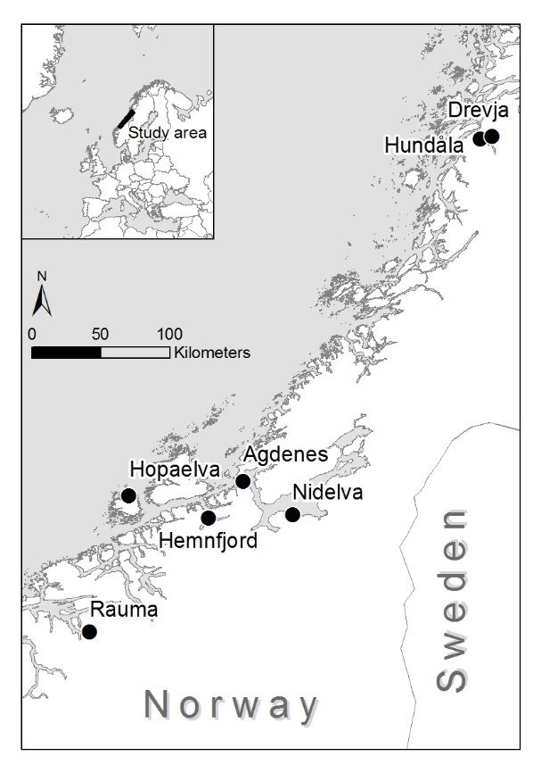
FIG1

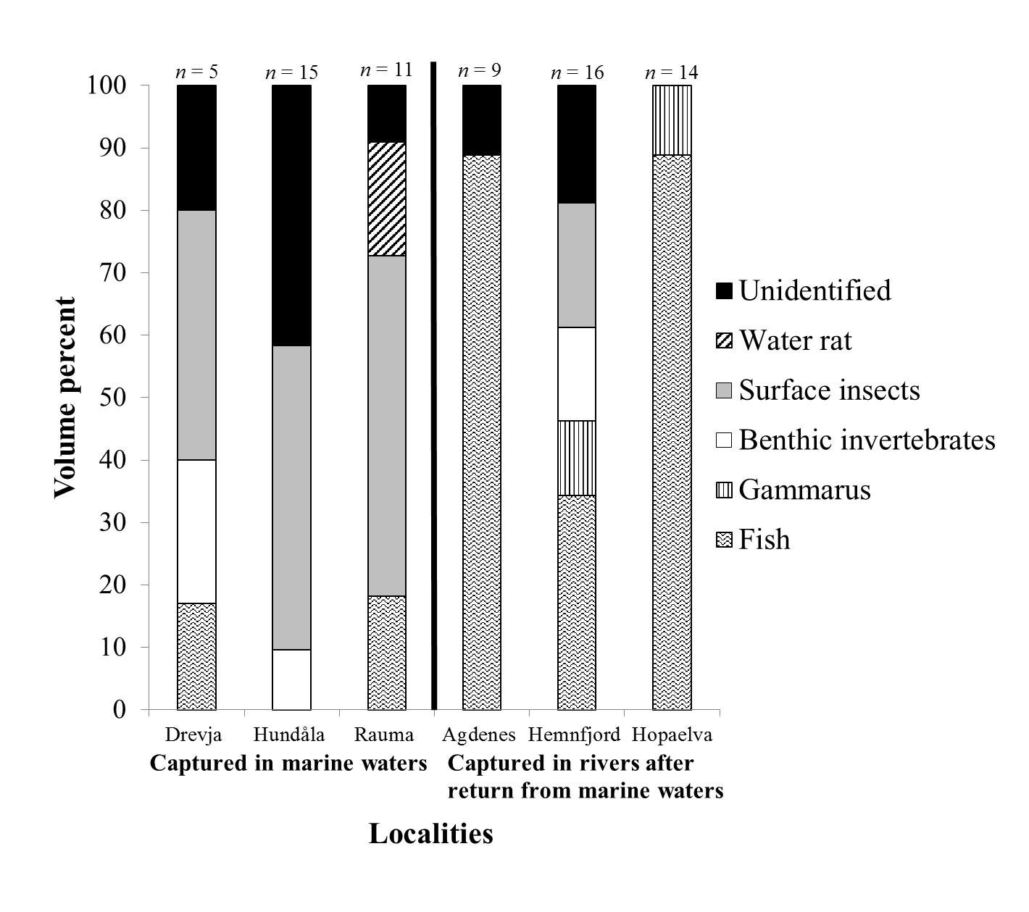FIG 2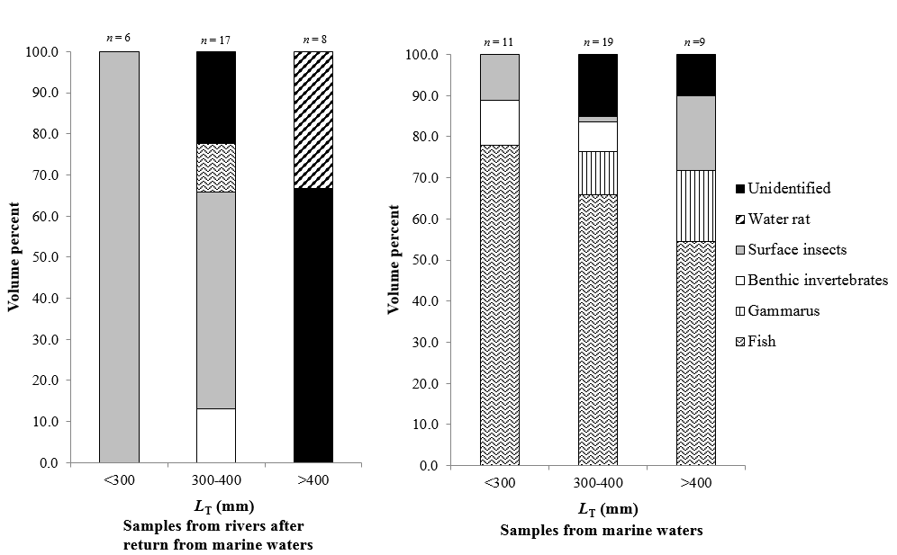FIG 3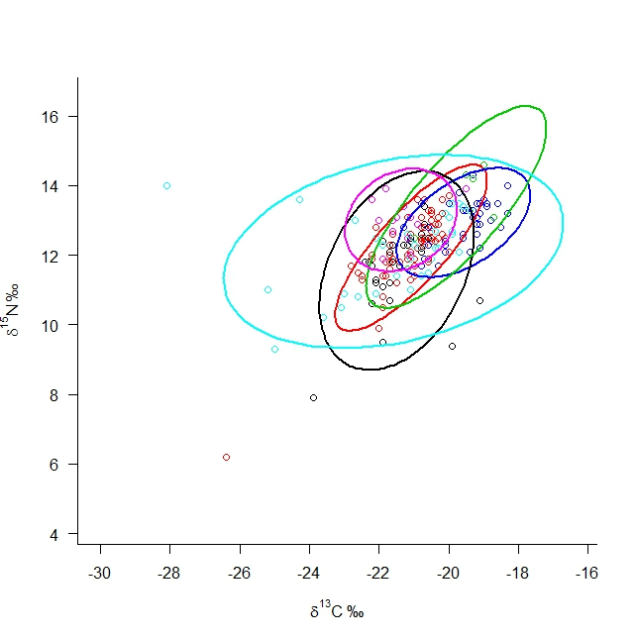FIG 4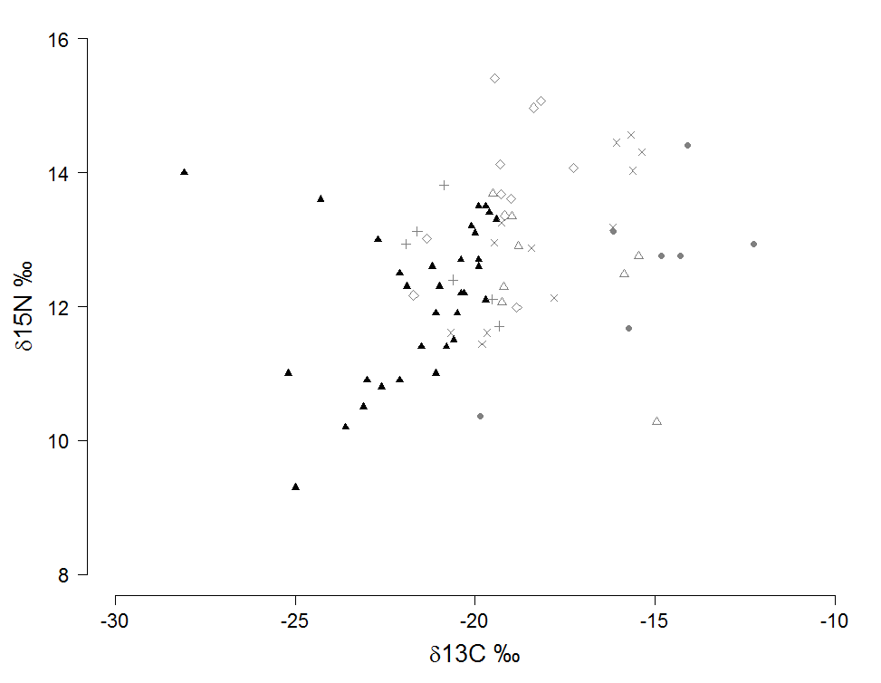
Fig 5

