Spatial configuration matters – a test of the Habitat Amount Hypothesis for plants in calcareous grasslands

Marianne Evju and Anne Sverdrup-Thygeson

M. Evju (Corresponding author) and A. Sverdrup-Thygeson
Norwegian Institute for Nature Research (NINA), Gaustadalléen 21, NO-0349 Oslo, Norway
e-mail: marianne.evju@nina.no
phone: +47 97 54 78 14/fax: + 47 73 80 14 01

A. Sverdrup-Thygeson
Department of Ecology and Natural Resource Management, Norwegian University of Life Sciences, P.O. Box 5003, NO-1432 Aas, Norway

Date of the manuscript draft: November 11, 2015
Date of the revised manuscript draft: March 30, 2016
Date of the second revised manuscript draft: June 15, 2016
Word count: 5817

Abstract
Context A recent hypothesis, the Habitat Amount Hypothesis, predicts that the total amount of habitat in the landscape can replace habitat patch size and isolation in studies of species richness in fragmented landscapes.
Objectives To test the Habitat Amount Hypothesis by first evaluating at which spatial scale the relationship between species richness in equal-sized sample quadrats and habitat amount was the strongest, and then test the importance of spatial configuration of habitat – measured as local patch size and isolation – when habitat amount was taken into account.
Methods A quasi-experimental setup with 20 habitat patches of dry calcareous grasslands varying in patch size, patch isolation and habitat amount at the landscape scale was established in the inner Oslo fjord, Southern Norway. We recorded species richness of habitat specialists of vascular plants in equal-sized sample quadrats and analysed the relationship between species richness, habitat amount in the landscape and patch size and isolation.
Results Although the total amount of habitat in a 3 km-radius around the local patch was positively related to species richness in the sample quadrats, local patch size had an additional positive effect, and the effect of patch size was higher when the amount of habitat within the 3 km-radius was high than when it was low.
Conclusions In our study system of specialist vascular plants in dry calcareous grasslands, we do not find support for the Habitat Amount Hypothesis.

Keywords
Connectivity, Conservation, Fragmentation, Habitat amount, Plant diversity, Spatial configuration
Introduction
Destruction and degradation of natural ecosystems is one of the major threats to biodiversity (Haddad et al. 2015), and understanding the dynamics of the resulting fragmented landscape has been one of the main themes in conservation biology the past 50 years (Saunders et al. 1991). One inherent challenge in conservation biology is distinguishing effects of habitat loss from effects of habitat fragmentation on biodiversity (Didham et al. 2012; Fahrig 2003), as the two processes typically occur simultaneously (Villard and Metzger 2014) and the amount of habitat in a landscape often is closely correlated with the degree of fragmentation (Andrén 1994; Fahrig 2003).
The species richness of a sample increases as the area of sampling increases (MacArthur and Wilson 1967). The species-area relationship (SAR) is commonplace in nature, across organism groups and spatial scales (see for example Matthews et al. 2014; Rosenzweig 1995; With 2016). In conservation biology, the SAR is used to understand and predict consequences of the loss and fragmentation of habitat, i.e. to explore how fast species are lost when habitats become increasingly fragmented (He and Hubbell 2011; Rybicki and Hanski 2013). That the number of species in a sample increases as the sample area increases has been termed the ‘sample area effect’ (Fahrig 2013), and mainly reflects that larger samples hold more individuals and consequently more species than smaller samples. According to the "Theory of Island Biogeography", the slope of the species-area relationship should be steeper in islands than in continuous habitats (Connor and McCoy 1979; MacArthur and Wilson 1967; With 2016). This ‘island effect’ (sensu Fahrig 2013) is due to lower colonization rates and higher extinction rates on small and remote islands. This implies that in equal-sized sample sites, the species richness should be lower in small and remote islands than in large and less isolated islands (Fahrig 2013).
In a recent paper, Fahrig (2013) casts doubt on the island effect in discontinuous habitats and challenges the concept of the patch as the natural unit for measurements of species richness in discontinuous habitat areas. She hypothesizes that patch size or patch isolation per se are not important for species richness in a sample site of a given size. Rather the summed amount of habitat at the landscape level affects species richness through the sample area effect. As the habitat amount in the landscape declines, the species richness will decrease because of the sample area effect, irrespective of the size or configuration of the remaining habitat patches. Consequently, samples taken from small habitat patches should contain the same number of species as samples of equal size taken from larger patches, if the amount of habitat in the landscape is the same. If this suggested Habitat Amount Hypothesis is correct, a single predictor of habitat amount can replace patch size and patch isolation in studies of species richness in fragmented landscapes.
The Habitat Amount Hypothesis refers to the “local landscape”, i.e. the immediate surroundings of a study plot. But it is not always straight-forward to decide on the relevant scale of a local landscape. This is especially challenging when the studied response is species richness and not a single species, as different species have individualistic response to landscape dynamics. Multi-scale analyses of nested scales have been proposed to find the spatial scale with a maximum fit of the species richness-habitat amount relationship, the ‘scale of effect’ (Fahrig 2013; Holland et al. 2004; Jackson and Fahrig 2015). But even when such a clear relationship can be found, does that mean that the configuration of habitat or amount of habitat at smaller or larger spatial scales is irrelevant to the species in question? In a reply to Fahrig, Hanski (2015) raises his concerns about the lack of consideration of the larger landscape and points to the significance of habitat configuration beyond the scale of the local landscape. Fahrig (Fahrig 2013; Fahrig 2015) calls for rigorous testing of the hypotheses against empirical data. In this paper, we do exactly that.
The hypothesis can be tested by designing a set-up where patch configuration and amount of habitat vary independently across sample sites within the local landscape. If patch size varies, but the amount of habitat in the local landscape around the sample sites is held constant, the hypothesis predicts that there should be no effect of patch size on species richness in the sample sites. If, however, the amount of habitat and patch size are negatively correlated, so that small patches have more habitat in the local landscape than large patches, the hypothesis predicts a positive effect of habitat amount on species richness in the sample sites, although the size of the habitat patch decreases (Fahrig 2013)
We test the Habitat Amount Hypothesis using species richness of habitat specialists of vascular plants in dry calcareous grasslands in Norway. In our study area, dry calcareous grasslands are naturally sparse and patchily distributed because they are confined to areas with certain bedrock qualities and climatic conditions. As the study area is the most densely populated area in Norway, anthropogenic pressure has further reduced the number of patches, their patch sizes and increased the distance between remaining patches.
We used a quasi-experimental approach where species richness was recorded in equal-sized sample quadrats in focal patches with varying patch size, distance to nearest neighbour patch and habitat amount in the local landscape. Quasi-experiments lend strength from both the observational and experimental design paradigms (Shadish et al. 2002). They share similarities with traditional experimental set-ups, but lack the element of random assignment to treatment, as this is not easily achieved in full-scale landscape studies.
We designed a focal patch multi-scale study to evaluate at which spatial scale the relationship between sample site richness and habitat amount was the strongest. Taking habitat amount in the local landscape into consideration, we then tested the importance of spatial configuration of habitat, i.e. local patch size and isolation (distance to nearest neighbour patch).
More specifically, we test the following three predictions from the habitat amount hypothesis:
- The species richness in the sample quadrats is positively related to habitat amount in the landscape due to the sample area effect
- There is no effect of local patch size per se on sample quadrat species richness, when habitat amount in the landscape is taken into consideration
- There is no effect of patch isolation − in terms of distance to nearest neighbour patch − on sample quadrat species richness, when habitat amount in the landscape is taken into consideration.

Methods
Habitat, study area and study species
Dry calcareous grasslands in Norway are restricted to sites with calcareous bedrock and a warm and dry climate. The habitat is frequently exposed to drought episodes due to a combination of high soil drainage and exposure to wind and sun, which combined with effects of land rise prevent the establishment of forest. In the southeast Norway, the habitat is confined to a narrow zone between the sea and forested inland areas, and this dependency on bedrock qualities, exposure and a warm and dry climate makes dry calcareous grasslands a naturally sparse and patchily occurring habitat. Dry calcareous grasslands occur as small (50−9,500 m²), distinct habitat patches that are easily delineated in the field (Evju et al. 2015), surrounded by a matrix of sea, seashore habitat, forest and urban and suburban areas.
The study was carried out in the inner Oslo fjord, in the counties of Oslo and Akershus, Norway (Fig. 1), the region in Norway with the highest occurrence of dry calcareous grasslands (Bakkestuen et al. 2014). The Oslo fjord area is also the most densely populated area of Norway. Human impact, primarily through housing and infrastructure development, has led to loss of natural habitats. Analyses of old aerial photographs suggest a loss of >60% of dry calcareous grassland area the last 80 years, with a reduction in habitat patch sizes and increased distances between remaining patches (Evju and Stange 2016). Today, dry calcareous grasslands constitute on average 1.3% of the landscape in a radius of 0.5 km around the habitat patches included in this study (see below), but only 0.1 % of the landscape in a radius of 7 km (M. Evju unpublished data).
Dry calcareous grasslands in the inner Oslo fjord have a high occurrence of nationally red-listed species, including vascular plants, lichens, fungi and invertebrates. To test the effects of the amount and configuration of dry calcareous grassland habitat on species richness, we used vascular plants, but included only species that are strictly confined to dry grasslands on calcareous bedrock in the study area, and excluded species occurring in a range of habitats. The list of habitat specialist species was defined based on the local flora (Lid and Lid 2005) and own knowledge of the species (Bakkestuen et al. 2014; Wollan et al. 2011a), and included 50 vascular plants (Evju et al. 2015).

Quasi-experimental set-up
To identify and delineate habitat patches – discrete fragments of habitat – of dry calcareous grasslands, we superimposed a grid system of 500 × 500 m plots on the study area, encompassing a total of 238 plots. Islands less than 0.25 km² were treated as one sampling unit even if they were intersected by the sampling grid (Fig. 1). We randomly selected 50 plots for field inspections, which were carried out in 2009−2011. In each plot, all habitat patches of dry calcareous grassland were delineated, the patch size determined and all vascular plants present recorded. A total of 93 patches were identified, occurring in 22 of the 50 randomly selected plots. As the mapping of dry calcareous grasslands in the study area is incomplete, we used a habitat distribution model (Wollan et al. 2011b) to predict the occurrence of habitat patches outside of the 50 investigated 500 × 500 m plots (Evju et al. 2015). From these data we calculated for each patch (1) the distance to the nearest neighbour patch, and (2) the amount of dry calcareous habitat (habitat amount) at eight different spatial scales, within radii of 0.5, 1, 2, 3, 4, 5, 6 and 7 km of the focal patch, including the area of the focal patch (Table 1). Seven km was chosen as the largest spatial scale, as this included the maximal spatial extent of the habitat in the study area.
A preliminary study was performed to determine what qualified as low vs. high connectivity in the context of this system, by evaluating this relative to the median degree of patch connectivity as assayed by Hanski’s patch connectivity measure (Hanski 1994), see Appendix 1 for details. We then used median values of patch size and connectivity of the 93 habitat patches to define “small” vs. “large” and “low” vs. “high” connectivity patches, respectively (Table 1), and randomly selected five patches from each of the categories “small with low connectivity”, “small with high connectivity”, “large with low connectivity”, and “large with high connectivity”. In this subset of 20 habitat more detailed field investigations of species richness and composition of vascular plants and invertebrates was carried out (M. Evju, A. Endrestøl and S. L. Olsen, unpublished manuscript).
We recorded the species richness of vascular plants in equal-sized quadrats of 0.5 × 0.5 m² in each habitat patch. The number of quadrats per patch was weighted with patch area, and between 7 and 13 quadrats per patch were sampled, giving a total of 201 quadrats over the 20 patches. All quadrats were analysed one time, and fieldwork was carried out in August 2012 (18 patches) and August 2013 (2 patches).
#Table 1 approximately here#
# Fig. 1 approximately here#

Statistical analyses
In order to investigate the strength of the relationships between the different spatial variables, we first calculated Pearson’s correlation coefficient r with 95% CI for each combination of the variables (Table 2). This analysis was done at the patch level (n = 20). Variables were log-transformed prior to analysis to ensure normal distribution.
Secondly, we investigated the strength of the relationship between species richness and habitat amount at different spatial scales, to identify the spatial scale where this relationship was strongest, the ‘scale of effect’. As we were interested in species richness in equal-sized samples, we used the number of species per quadrat. We used resampling techniques where we randomly sampled one quadrat from each habitat patch and calculated Pearson’s correlation coefficient r, repeating this 2000 times. We used the mean value of r from this resampling as our measure of relationship strength as suggested by Holland et al. (2004).
Thirdly, we explored if species richness in equal-sized samples was related to patch size when habitat amount at the spatial scale with strongest relationship with species richness was taken into account. Because we sampled several quadrats per patch, and the number of quadrats per patch varied with patch size, we used linear mixed-effect models (LME) and included patch ID as a random factor, to adjust for the uneven sampling effort among patches and the spatial dependency of quadrats within patches. Standard multiple regressions have been shown to perform well in order to obtain measures of the relative importance of habitat amount and habitat fragmentation also when predictor variables are correlated (Smith et al. 2009). To facilitate the interpretation of the relative importance of the predictors in the model, we centred and scaled both the response variable and the predictor variables prior to analysis (Nakagawa and Cuthill 2007; Schielzeth 2010). We standardized the variables by one standard deviation, as recommended by Schielzeth (2010). We constructed a linear mixed-effect model with the maximum likelihood method, and compared the AICc values, ΔAICc values and AICc weights (Burnham and Anderson 2002) of three competing models. All models had species richness in the quadrat as the response variable and different combinations of predictor variables; habitat amount only (model 1), habitat amount and patch size (model 2), and habitat amount, patch size and their interaction (model 3).
Similarly, we explored the effect of patch isolation (distance to nearest neighbour patch) when habitat amount was taken into account.
Finally, we investigated the relative importance of habitat amount, patch size and distance to nearest neighbour patch for explaining species richness in the sample quadrats. We constructed 13 alternative linear mixed-effect models with the maximum likelihood method, with species richness as the response variable and combinations of habitat amount, patch size and distance to nearest neighbour, including two-way interactions, as predictor variables (Appendix 2). Alternative models were compared by ΔAICc values and AICc weights.
We inspected model validation plots to ensure normal distribution of residuals and homoscedasticity. Centring and scaling of all input variables ensured that the assumptions for running linear analyses were met. Analyses were performed in R version 3.2.2 (R Core Team 2015) using the packages nlme (Pinheiro et al. 2013) and AICcmodavg (Mazerolle 2016).

Results
Covariation among predictor variables
There was a positive correlation between the size of the habitat patch and the amount of habitat at the smallest spatial scales (0.5 and 1 km radius, Table 2), reflecting that at these spatial scales habitat amount to a large degree reflected habitat patch size in this study system. The relationship strength between habitat patch size and habitat amount at spatial scales above 1 km around the focal patch was low, suggesting that patch size and habitat amount varied independently when zooming out at a larger landscape scale. The distance to nearest neighbour patch was generally smaller for large than for small patches (negative relationship), and also covaried with habitat amount at the smallest spatial scales (0.5 to 1 km radius).
#Table 2 approximately here#

Species richness and habitat amount at different spatial scales – the scale of effect
The relationship between species richness in sample quadrats and habitat amount was positive and stable at the spatial scales from 0.5 to 4 km radius, with a mean effect size peaking at 0.30 at 1 and 3 km (Fig. 2), and with a clear decline at spatial scales above 4 km. As habitat amount at the 1 km-scale in large reflected focal patch size (Table 2), the 3 km-scale was chosen to reflect the “scale of effect”, i.e. the spatial scale where the amount of habitat in the landscape had the largest effect on species richness in the sample quadrats.
#Fig. 2 approximately here#

Effect of habitat amount vs. habitat configuration
Species richness in the sample quadrats increased with increasing habitat amount within 3 km of the focal patch, but the model also including patch size was more than six times as likely to be the best explanation for species richness as the model with habitat amount alone (Table 3a). The model including an interaction term between patch size and habitat amount had lower AICc weight than the simpler model, but suggests that species richness increased slightly more with patch size when the amount of habitat within the 3 km-radius was high than when it was low (Fig. 3, Table 3a).
In contrast, including distance to nearest neighbour and the interaction between distance and habitat amount as predictor variables did not improve the model of species richness in sample quadrats compared to a model including only habitat amount in a 3 km-radius (Table 3b).
Comparing 13 alternative models including habitat amount and different combinations of patch size, distance to nearest neighbour and two-way interaction terms confirmed the relatively larger importance of habitat amount and patch size than of distance to nearest neighbour (Table 4, Appendix 2). The model including only habitat amount and patch size was almost eight times as likely to be the best model as the model including also patch isolation.
#Fig. 3 approximately here#
#Table 3 approximately here#
#Table 4 approximately here#

Discussion
Our results indicate that for fragmented dry calcareous grasslands in Southern Norway, the size and partly the isolation of the focal patch exert important added effects to the amount of habitat on species richness of plants. On the condition that patch size and nearest-neighbor distances are interpreted as spatial configuration metrics, our results thus suggest that the spatial configuration of habitat patches is having a clear effect on species richness of vascular plants in equal-sized sample quadrats. Even when habitat amount in the landscape was taken into consideration, local patch size had a significant positive added effect.
This is contrary to the predictions from the Habitat Amount Hypothesis (Fahrig 2013), which states that only the total amount of habitat in the landscape matters, not the sizes of the patches that make up that total. In conclusion, this means that we do not find support for the Habitat Amount Hypothesis in our study system.

Scaling issues
Scale is a central issue in conservation and ecology (Wiens 1989), and the spatial extent we chose for measurements can affect the outcome of our study (Sverdrup-Thygeson et al. 2014). Therefore, including a range of spatial scales and then selecting the scale that yields the strongest species-landscape relationship is recommended (Holland et al. 2004; Jackson and Fahrig 2015).
In our system, we tested the strength of the relationship between species richness and habitat amount for eight spatial scales (from 0.5 to 7 km radius). The relationship strength with species richness was relatively stable for spatial scales from 0.5 to 4 km but then declined, suggesting that at larger spatial scales than 4 km, habitat amount is of minor importance to quadrat-level species richness. As the smallest spatial scales (0.5 and 1 km) mainly reflected local patch size, and we wanted to test the separate effect of patch size and habitat amount, we defined the 3 km-scale to best reflect the ‘scale of effect’, i.e. the spatial scale where the amount of habitat in the landscape had the largest effect on species richness in the sample quadrats (Fig. 2). Still, we are aware that finding a single appropriate scale, especially in multi-species studies, is not straightforward. The effect of different processes on species richness may overlap in space or time, making it difficult to separate their effects (Alofs et al. 2014). Even the distinction between local effects and ‘local landscape’-effects is not clearcut, and is partly a question of definition. For our study system it seems relevant to think of the 3 km-scale as reflecting habitat amount within the ‘local landscape’ rather than an extended patch-based measure: Our study organisms are sedentary and have been shown to have limited dispersal capacities (Evju et al. 2015). Thus, they mostly relate to their immediate surroundings.

Habitat amount and habitat configuration are both important
As expected, species richness in the sample quadrats increased with total habitat amount in the local landscape, in accordance with the sample-area effect (sensu Fahrig 2013), confirming our first hypothesis. However, our second prediction, that there would be no effect of habitat configuration when habitat amount is accounted for, was not supported. Local patch size did have an additional positive effect on the species richness in the sample quadrats. For a given amount of habitat in the landscape, the quadrat-level species richness will thus be lower in small as compared to large habitat patches. Also, we found an interaction between habitat amount and patch size suggesting that species richness increases more with increasing amounts of habitat when the local patch is large.
These results suggest that species richness at the quadrat-level is controlled by mechanisms operating at multiple spatial scales. Several explanations have been proposed to explain the positive relationship between species richness and habitat area. Niche theory focuses on environmental heterogeneity and the role of deterministic niche partitioning as a major driver of species richness patterns (Silvertown 2004): as area increases, so does the total habitat heterogeneity – resulting in more species (Williams 1943). Classical island biogeography theory rather focuses on the stochastic and neutral processes of immigration and extinction related to size and isolation of the habitat in question (MacArthur and Wilson 1967): increasing size means larger populations, which are less prone to local extinctions. Positive effects of habitat amount on species richness when sampled in equal-sized plots have been demonstrated in several studies (see Fahrig 2013 and references therein). In plants, the empirical evidence of increasing species richness with increasing habitat amount is scarce when comparing equal sized samples (Giladi et al. 2014; Köchy and Rydin 1997), but it is demonstrated in some studies (see for instance Cousins and Vanhoenacker 2011; Munguia-Rosas and Montiel 2014).
Habitat heterogeneity or colonization-extinction processes also control species richness on the local patch scale (Pärtel et al. 1996; Reitalu et al. 2012). The different slopes of species richness as a function of habitat amount for large and small habitat patches suggest that extinction-colonization ratios are affected as patch sizes decreases, even though the habitat amount in the local landscape is constant (i.e. the 'island effect', Fahrig 2013). As dispersal and establishment is frequently higher in the immediate surroundings of an existing plant individual (Cain et al. 2000), reduced within-patch population size and higher within-patch extinction risks could be expected in small habitat patches. Also, as immigration to isolated patches is reduced, there will be less chance of a rescue effect (sensu Brown and Kodric-Brown 1977) in isolated patches. Indeed, in a simulation study, Rybicki and Hanski (2013) found that although species richness relates to habitat amount, the configuration of the habitat is important, particularly when the total habitat amount is small. Similarly, Coudrain et al. (2014) found a stronger negative effect of patch isolation on species richness in landscapes with low amount of habitat. In our study system, less than 1% of the land cover in a 3 km-radius surrounding the studied habitat patches is dry calcareous grasslands, and each habitat patch is small, the smallest being only 50 m².
Populations in small habitat patches might also experience a higher degree of negative influence from the matrix than larger patches, even in landscapes with similar amounts of habitat on a 3 km-scale. These influences could be abiotic, like decreasing sun exposure due to encroaching shrub vegetation, or biotic, such as competition from generalist species (Fischer and Lindenmayer 2007). In our study area, invasive species seem to be more abundant in small than in large habitat patches (Evju and Stange 2016), possibly amplifying negative effects on small populations of specialist species.
As species differ in capacities for dispersal, establishment and persistence, the spatial scales of habitat amount in the landscape affecting the occurrence of different species could be expected to vary (Cousins and Vanhoenacker 2011; Ewers and Didham 2006; Franzén et al. 2012; Holland et al. 2004). For example, Franzén et al. (2012) found that specialist species were particularly sensitive to changes in area, while highly mobile generalists were less sensitive to area, with species-area relationships resulting from deterministic trait-mediated area-dependencies rather than just neutral effects of immigration and extinction. Taking into consideration species-specific dispersal capacities, a given 3 km-radius landscape may therefore contain true populations of some species and meta-populations or even isolated populations of others.
In a previous study in the same study system, we found that the probability of occurrence of habitat specialist plants was related to species traits, and that plants with short lifespan and low seed production are particularly sensitive to increasing isolation of the habitat patches (Evju et al. 2015). The species richness patterns observed are thus results of processes operating at several important spatial scales. In order to disentangle these effects, more knowledge of population dynamic responses of different species to habitat fragmentation is needed (Wilson et al. 2016).

Testing the Habitat Amount Hypothesis
In our study system, we do find a separate effect of habitat configuration. Local patch size has an additional positive effect on species richness to that of habitat amount. Additionally, the effect of patch size is higher when the amount of habitat within the 3 km-radius is high than when it is low.
Fahrig’s Habitat Amount Hypothesis states that patch characteristics like size or isolation are not important for explaining species richness in a sample site. It assumes that one single important predictor − the total amount of habitat at the landscape level – is sufficient.
In his critique of the Habitat Amount Hypothesis, Hanski (2015) raises four main concerns: Firstly, that ‘local landscape’ is a too narrow perspective. For our study, the scale of effect resembles the true extent of this rare habitat in Norway, so this point is not so relevant for our study. Secondly, Hanski addresses the challenge of multispecies studies in space, and suggests focusing on single species with well-known ecologies in order to understand the mechanisms behind the patterns. Our study strikes a balance between these two options, by focusing on a small set of specialist species with similar life history traits (Evju et al. 2015).
The two final points made by Hanski (2015) relates to the fact that many present landscapes are heavily fragmented, and consist mainly of small and isolated fragments, and these are the systems where we expect the most effect of spatial configuration. This might be exactly the reason why we find a separate effect of habitat configuration in our study, as it is a system of high natural and anthropogenic degree of isolation.

Conclusion
We conclude that with decreasing habitat amount, population persistence in small habitat patches is reduced compared to large patches, and species richness is reduced. Thus, we do not find support for the Habitat Amount Hypothesis in our study system of specialist vascular plants in dry calcareous grasslands. Further research should focus on identifying under which conditions and scales it is important to consider spatial configuration in addition to total habitat amount. In an applied context, our results emphasize the importance of both protecting large habitat patches and maintaining a high amount of habitat in the local landscape around the patches.

Acknowledgements
This study was carried out under the projects ‘‘Survey and monitoring of red-listed species’’ (ARKO, funded by the Norwegian Environment Agency), and ‘‘Management of biodiversity and ecosystem services in spatially structured landscapes’’ (funded by the Norwegian Research Council, grant 208434/F40). We are grateful to A. Often, O. Skarpaas, O.E. Stabbetorp and J. Wesenberg for fieldwork contributions, and to three referees for valuable comments to earlier versions of this manuscript.

Tables
Table 1. Spatial characteristics of the 20 patches of dry calcareous grasslands included in the quasi-experimental study.
VARIABLE | MEAN | MEDIAN | MIN | MAX
Patch size (m²) | 662 | 558 | 50 | 2,302
Connectivity | 1.5 | 1.1 | 0.06 | 3.9
Distance to nearest neighbour patch (m) | 90 | 31 | 1 | 664
Habitat amount 0.5 km (m²) | 10,205 | 9,405 | 50 | 23,783
Habitat amount 1 km (m²) | 15,011 | 15,326 | 1,419 | 33,161
Habitat amount 2 km (m²) | 35,567 | 40,021 | 4,003 | 61,753
Habitat amount 3 km (m²) | 52,605 | 54,168 | 8,682 | 77,952
Habitat amount 4 km (m²) | 74,234 | 80,810 | 10,884 | 99,362
Habitat amount 5 km (m²) | 104,015 | 109,492 | 14,891 | 132,515
Habitat amount 6 km (m²) | 126,911 | 125,777 | 45,705 | 166,396
Habitat amount 7 km (m²) | 149,210 | 142,166 | 67,477 | 221.074
Quadrat-level species richness | 4.5 | 4 | 0 | 12

Table 2. Strength of relationship between the spatial variables, measured as Pearson’s correlation coefficient r, with 95 % confidence intervals. Confidence intervals not overlapping with zero are in bold. All variables were log-transformed in the calculations. HA = habitat amount in the given radius around the focal patch.
 | Patch size | Distance to nearest | HA 0.5km | HA 1km | HA 2km | HA 3km | HA 4km | HA 5km | HA 6km
Distance to nearest | −.640  −.843,−.275
HA 0.5km | .589  .198,.818 | −.690  −.868,−.356
HA 1km | .471  .035,.756 | −.509  −.777,−.086 | .866  .687,.946
HA 2km | .274  −.191,.639 | −.351  −.687,.108 | .672  .327,.859 | .894  .747,.958
HA 3km | .195  −.271,.589 | −.275  −.640,.190 | .597  .210,.822 | .766  .489,.902 | .927  .821,.971
HA 4km | .018  −.428,.457 | −.159  −.562,.304 | .445  .003,.741 | .636  .270,.842 | .833  .619,.932 | .952  .880,.981
HA 5km | −.204  −.593, .262 | −.024  −.462,.423 | .217  −.249,.602 | .404  −.046,.718 | .586  .195,.817 | .731  .426,.887 | .880  .716,.952
HA 6km | −.111  −.528,.348 | −0.002  −.444,.441 | .263  −.203,.632 | .497  .070,.770 | .619  .243,.833 | .628  .258,.838 | .738  .439,.890 | .892  .742,.957
HA 7km | −.046  −.479,.405 | .014  −.431,.454 | .292  −.173,.650 | .514  .093,.779 | .573  .175,.810 | .514  .093,.780 | .582  .188, .815 | .723  .412, .883 | .945  .865, .979

Table 3. Results of linear mixed modelling of species richness in the sample quadrat as function of habitat amount in a 3 km-radius of the focal patch, testing the additional effect of (a) local patch size, and (b) distance to nearest neighbour patch. Predictor and response variables were centred and scaled prior to analysis (see the text for details). Values are least square estimates ± standard errors. The Akaike Information Criterion (AICc), difference in AICc from the best model (ΔAICc) and AICc weight are shown for each set of models. Parameter estimates of random factors (plot nested in patch) are not shown.
(a)
 | Model 1 | Model 2 | Model 3
Habitat amount 3 km | 0.330 ± 0.098 | 0.311 ± 0.082 | 0.312 ± 0.077
Patch size |  | 0.247 ± 0.084 | 0.219 ± 0.080
Habitat amount × patch size |  |  | 0.129 ± 0.072
AICc | 544.47 | 540.86 | 541.95
ΔAICc | 3.61 | 0.00 | 1.09
AICc weight | 0.094 | 0.574 | 0.332
(b)
 | Model 1 | Model 2 | Model 3
Habitat amount 3 km | 0.330 ± 0.098 | 0.285 ± 0.101 | 0.249 ± 0.096
Distance to nearest patch |  | −0.122 ± 0.094 | −0.348 ± 0.152
Habitat amount × distance |  |  | −0.170 ± 0.093
AICc | 544.47 | 546.45 | 547.52
ΔAICc | 0.00 | 1.98 | 3.04
AICc weight | 0.629 | 0.234 | 0.137

Table 4. Results of linear mixed modelling of species richness in the sample quadrat as function of habitat amount in a 3 km-radius of the focal patch, testing alternative combinations of patch size, distance to nearest neighbour patch and two-way interactions. The models shown represent the 95 % confidence set of models, with number of parameters (K), Akaike Information Criterion (AICc), difference in AICc from the best model (ΔAICc) ranked according to AICc weight. For a full set of models, see Appendix 2. Hab.am is habitat amount, size is patch size of the focal patch, and distance is distance to the nearest neighbour patch. Predictor and response variables were centred and scaled prior to analysis (see the text for details).
Rank | Model | K | AICc | ΔAICc | AICc weight
1 | Hab.am + size | 5 | 540.86 | 0.00 | 0.469
2 | Hab.am + size + hab.am × size | 6 | 541.95 | 1.09 | 0.272
3 | Hab.am | 4 | 544.47 | 3.61 | 0.077
4 | Hab.am + size + distance | 6 | 544.95 | 4.09 | 0.061
5 | Hab.am + size + distance + hab.am × size | 7 | 545.33 | 4.47 | 0.050
6 | Hab.am + distance | 5 | 546.45 | 5.59 | 0.029

Figure captions
Fig. 1. Study area location in Norway (upper left), an overview of the study area with the superimposed grid, with randomly selected 500 × 500 m plots marked in bold (right) and a zoom-in on one 500 x 500 plot with delineated habitat patches (lower left). Within each habitat patch, species richness was sampled in quadrats of 0.5 × 0.5 m².

Fig. 2. Relationship between species richness at the plot level and habitat amount at different spatial scales, evaluated as the mean correlation coefficient (Pearson’s r) between species richness in sample quadrats and habitat amount at the given scale, estimated with resampling techniques. In each iteration, one quadrat from each habitat patch was randomly sampled and the correlation between species richness and habitat amount calculated. Each mean value of r is based on 2000 resamples of the dataset.

Fig. 3. Fitted regression line for the relationship between habitat amount in a 3 km radius around the sample quadrat and species richness of vascular plants confined to dry calcareous grasslands at the quadrat level, averaged for small and large habitat patches, defined as below and above median patch size, respectively. Small grey dots represent each sample quadrat.

Figures

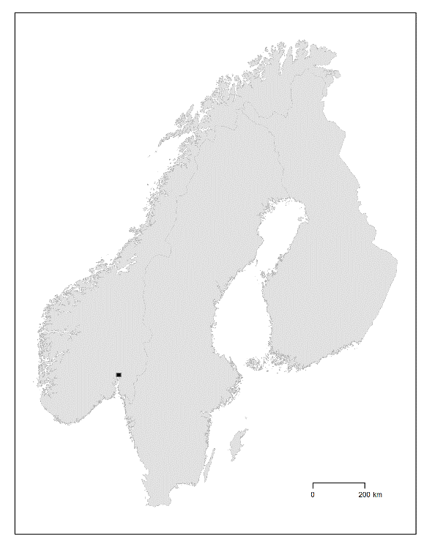
Fig. 1

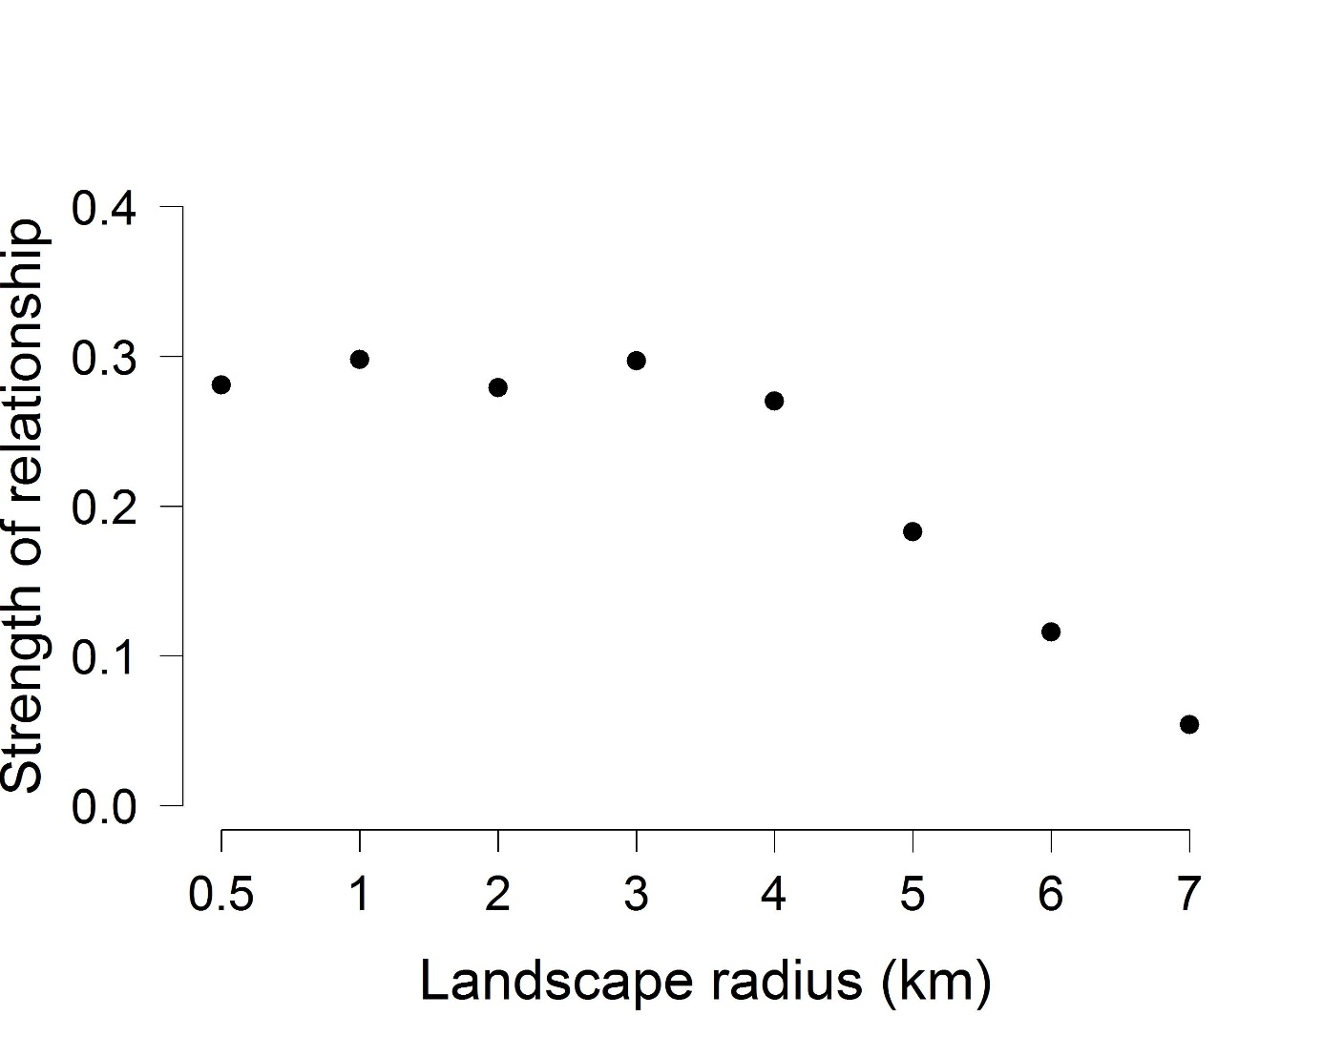
Fig. 2

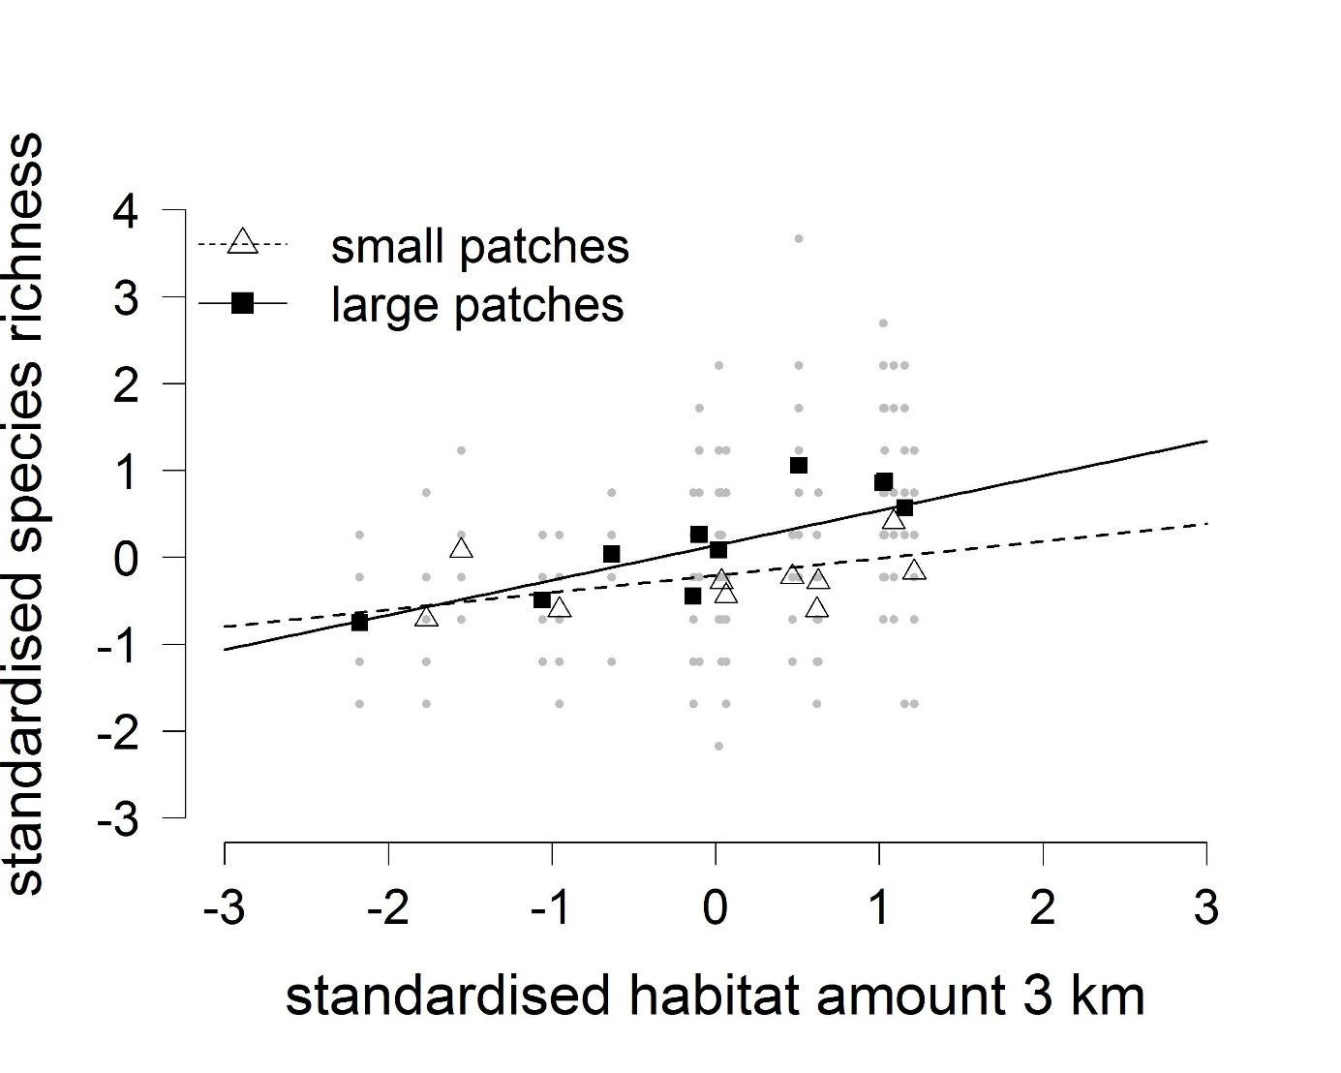

Fig. 3

References
Alofs K, González A, Fowler N (2014) Local native plant diversity responds to habitat loss and fragmentation over different time spans and spatial scales. Plant Ecol 215:1139-1151 doi:10.1007/s11258-014-0372-5
Andrén H (1994) Effects of habitat fragmentation on birds and mammals in landscapes with different proportions of suitable habitat: a review. Oikos 71:355-366
Bakkestuen V, Stabbetorp O, Molia A, Evju M (2014) The hotspot dry calcareous grassland in the Oslofjord region. Description of the habitat and a monitoring method developed in the ARKO project. NINA Report 1102.
Brown JH, Kodric-Brown A (1977) Turnover rates in insular biogeography: Effect of immigration on extinction. Ecology 58:445-449
Burnham KP, Anderson DR (2002) Model selection and multimodel inference: a practical information-theoretic approach. Springer, New York
Cain ML, Miligan BG, Strand AE (2000) Long-distance seed dispersal in plant populations. Am J Bot 87:1217-1227
Connor EF, McCoy ED (1979) The statistics and biology of the species-area relationship. Am Nat 13:791-833
Coudrain V, Schüepp C, Herzog F, Albrecht M, Entling MH (2014) Habitat amount modulates the effect of patch isolation on host-parasitoid interactions. Front Environ Sci 2:1-8
Cousins SAO, Vanhoenacker D (2011) Detection of extinction debt depends on scale and specialisation. Biol Conserv 144:782-787 doi:10.1016/j.biocon.2010.11.009
Didham RK, Kapos V, Ewers RM (2012) Rethinking the conceptual foundations of habitat fragmentation research. Oikos 121:161-170 doi:10.1111/j.1600-0706.2011.20273.x
Evju M, Blumentrath S, Skarpaas O, Stabbetorp OE, Sverdrup-Thygeson A (2015) Plant species occurrence in a fragmented landscape: the importance of species traits. Biodiv Conserv 24:547-561 doi:DOI: 10.1007/s10531-014-0835-y
Evju M, Stange E (eds) (2016) Når artenes leveområder splittes opp - eksempler fra øyene i indre Oslofjord. Sluttrapport fra strategisk instituttsatsing (SIS) 2011-2015. NINA Temahefte 65,
Ewers RM, Didham RK (2006) Confounding factors in the detection of species responses to habitat fragmentation. Biol Rev 81:117-143
Fahrig L (2003) Effects of habitat fragmentation on biodiversity. Ann Rev Ecol Evol Syst 34:487-515 doi:10.1146/annurev.ecolsys.34.011802.132419
Fahrig L (2013) Rethinking patch size and isolation effects: the habitat amount hypothesis. J Biogeogr 40:1649-1663
Fahrig L (2015) Just a hypothesis: a reply to Hanski. J Biogeogr 42:993-994 doi:10.1111/jbi.12504
Fischer J, Lindenmayer DB (2007) Landscape modification and habitat fragmentation: a synthesis. Glob Ecol Biogeogr 16:265-280 doi:10.1111/j.1466-8238.2007.00287
Franzén M, Schweiger O, Betzholtz P-E (2012) Species-area relationships are controlled by species traits. PLOS One 7:e37359
Giladi I, May F, Ristow M, Jeltsch F, Ziv Y (2014) Scale-dependent species-area and species-isolation relationships: a review and a test study from a fragmented semi-arid agro-ecosystem. J Biogeogr 41:1055-1069 doi:10.1111/jbi.12299
Haddad NM et al. (2015) Habitat fragmentation and its lasting impact on Earth’s ecosystems. Science Adv 1
Hanski I (1994) Patch-occupancy dynamics in fragmented landscapes. Trends Ecol Evol 9:131-135 doi:10.1016/0169-5347(94)90177-5
Hanski I (2015) Habitat fragmentation and species richness. J Biogeogr 42:989-993
He FL, Hubbell SP (2011) Species-area relationships always overestimate extinction rates from habitat loss. Nature 473:368-371 doi:10.1038/nature09985
Holland JD, Bert DG, Fahrig L (2004) Determining the spatial scale of species' response to habitat. Bioscience 54:227-233
Jackson HB, Fahrig L (2015) Are ecologists conducting research at the optimal scale? Glob Ecol Biogeogr 24:52-63
Köchy M, Rydin H (1997) Biogeography of vascular plants on habitat islands, peninsulas and mainlands in an east-central Swedish agricultural landscape. Nord J Bot 17:215-223 doi:10.1111/j.1756-1051.1997.tb00311.x
Lid J, Lid DT (2005) Norsk flora. 7 edn. Det Norske Samlaget, Oslo
MacArthur RH, Wilson EO (1967) The theory of island biogeography. Princeton University Press, Princeton
Matthews TJ, Cottee-Jones HE, Whittaker RJ (2014) Habitat fragmentation and the species-area relationship: a focus on total species richness obscures the impact of habitat loss on habitat specialists. Diversity Distrib 20:1136-1146
Mazerolle MJ (2016) AICcmodavg: Model selection and multimodel inference based on (Q)AIC(c). R package version 2.0-4. http://CRAN.R-project.org/package=AICcmodavg
Munguia-Rosas MA, Montiel S (2014) Patch size and isolation predict plant species density in a naturally fragmented forest. PLOS One 9 doi:10.1371/journal.pone.0111742
Nakagawa S, Cuthill IC (2007) Effect size, confidence interval and statistical significance: a practical guide for biologists. Biol Rev 82:591-605 doi:10.1111/j.1469-185X.2007.00027.x
Pinheiro J, Bates D, DebRoy S, Sarkar D, R Development Core Team (2013) nlme: Linear and nonlinear mixed effect models. R package version 3.1-109.
Pärtel M, Zobel M, Zobel K, van der Maarel E (1996) The species pool and its relation to species richness: Evidence from Estonian plant communities. Oikos 75:111-117 doi:10.2307/3546327
R Core Team (2015) R: a language and environment for statistical computing. R Foundation for Statistical Computing, Vienna, Austria. http://www.R-project.org/
Reitalu T, Purschke O, Johansson LJ, Hall K, Sykes MT, Prentice HC (2012) Responses of grassland species richness to local and landscape factors depend on spatial scale and habitat specialization. J Veg Sci 23:41-51 doi:10.1111/j.1654-1103.2011.01334.x
Rosenzweig ML (1995) Species diversity in space and time. Cambridge University Press, Cambridge
Rybicki J, Hanski I (2013) Species-area relationships and extinctions caused by habitat loss and fragmentation. Ecol Lett 16:27-38 doi:10.1111/ele.12065
Saunders DA, Hobbs RJ, Margules CR (1991) Biological consequences of ecosystem fragmentation - a review. Conserv Biol 5:18-32
Schielzeth H (2010) Simple means to improve the interpretability of regression coefficients. Methods Ecol Evol 1:103-113
Shadish WR, Cook TD, Campbell DT (2002) Experimental and quasi-experimental designs for generalized causal inference. Houghton Mifflin, Boston
Silvertown J (2004) Plant coexistence and the niche. 19:605-611
Smith AC, Koper N, Francis CM, Fahrig L (2009) Confronting collinearity: comparing methods for disentangling the effects of habitat loss and fragmentation. Landscape Ecol 24:1271-1285 doi:10.1007/s10980-009-9383-3
Sverdrup-Thygeson A, Gustafsson L, Kouki J (2014) Spatial and temporal scales relevant for conservation of dead-wood associated species: current status and perspectives. Biodiv Conserv 23:513-535 doi:10.1007/s10531-014-0628-3
Villard M-A, Metzger JP (2014) Beyond the fragmentation debate: a conceptual model to predict when habitat configuration really matters. J Appl Ecol 51:309-318 doi:10.1111/1365-2664.12190
Wiens JA (1989) Spatial scaling in ecology. Func Ecol 3:385-397
Williams CB (1943) Area and the number of species. Nature 152:262-265
Wilson MC et al. (2016) Habitat fragmentation and biodiversity conservation: key findings and future challenges. Landscape Ecol 31:219-227 doi:10.1007/s10980-015-0312-3
With KA (2016) Are landscapes more than the sum of their patches? Landscape Ecol in press doi:10.1007/s10980-015-0328-8
Wollan AK et al. (2011a) Open calcareous ground with shallow soil in the Oslo fjord region - a hotspot habitat. Final report from period II of the ARKO project. NINA Report 713.
Wollan AK, Bakkestuen V, Halvorsen R (2011b) Spatial predictive modelling of dry calcareous grasslands in the Oslofjord area. In: Halvorsen R (ed) The scientific basis for habitat monitoring in Norway - baseline surveys. University of Oslo, Natural History Museum, pp 176-196

